**Maven Project**

1.Start with Eclipse IDE

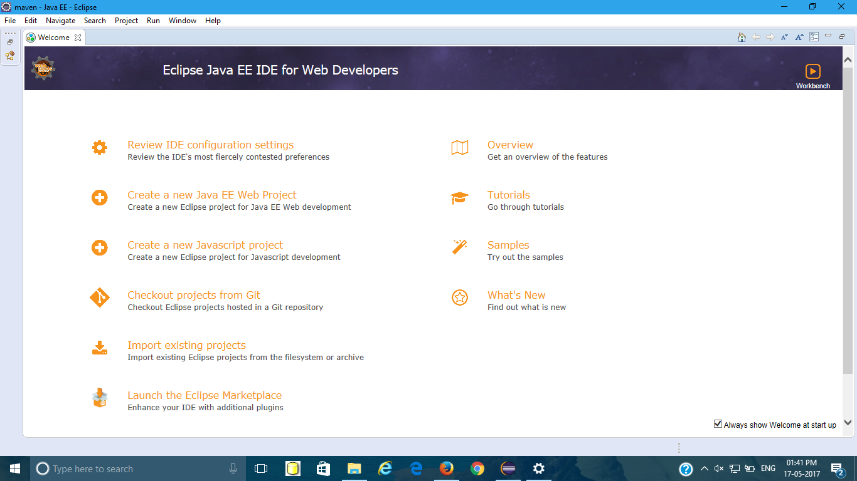

2.Select file🡪New🡪Maven Project.

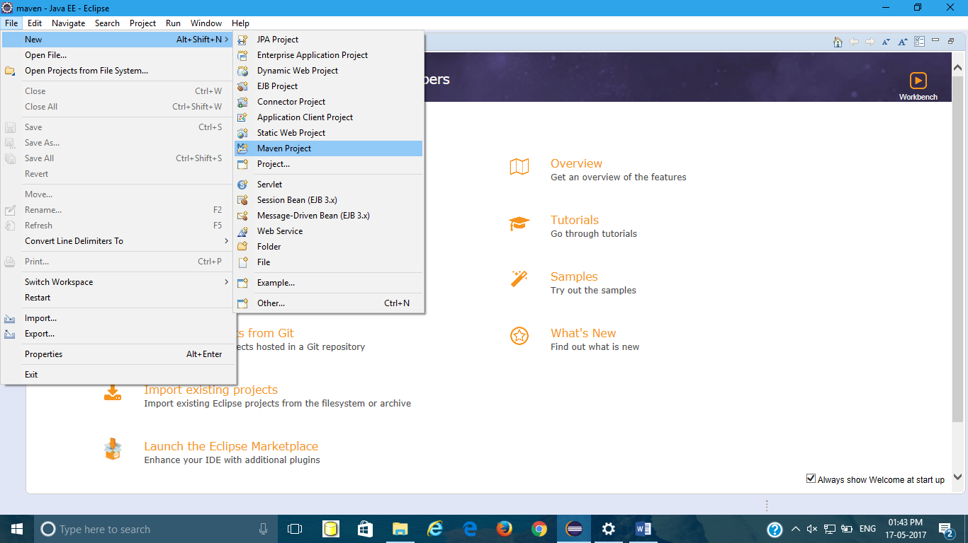

3.Select Next

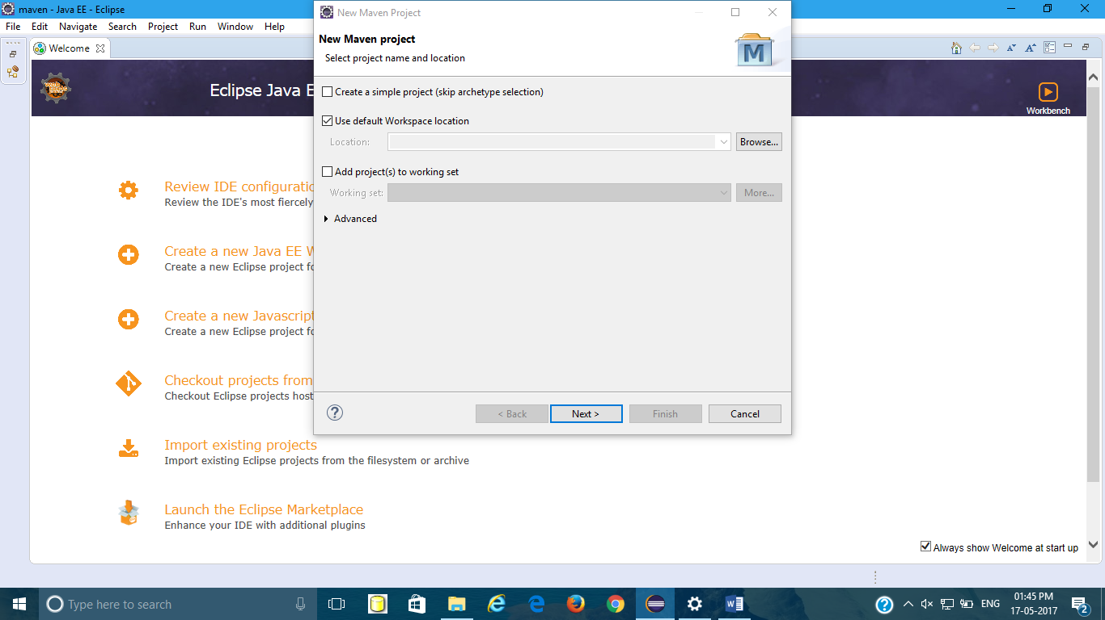

4.Select An archetype which contains a sample Maven Webapp project and click on Next. 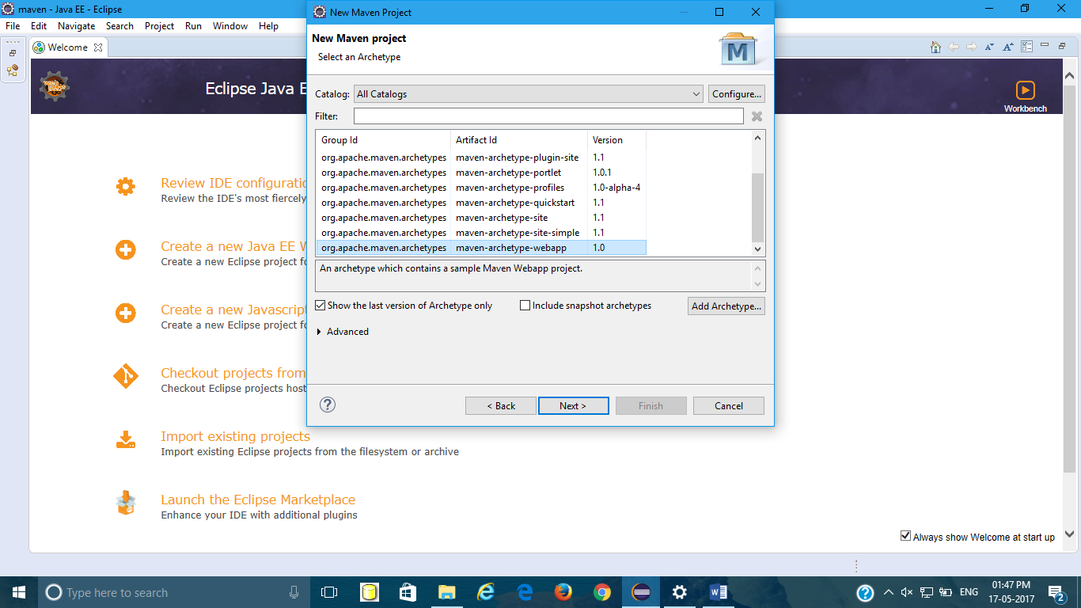

5.Enter groupId,artifact id and version and select finish.

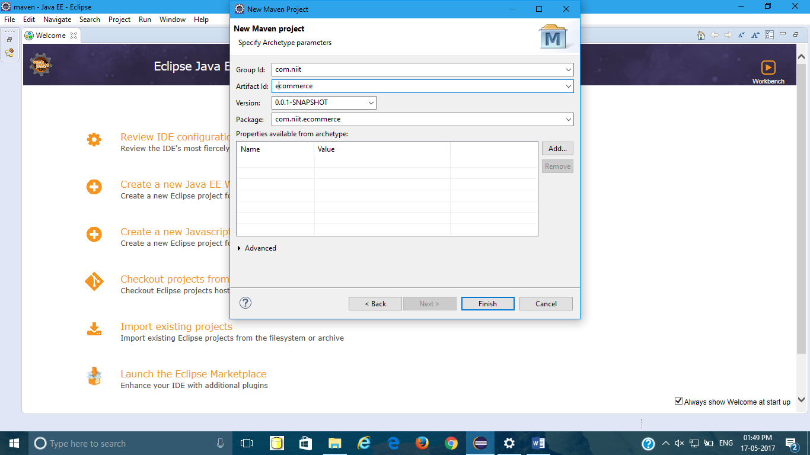

6.Then you can see your project like this in Project Explorer.

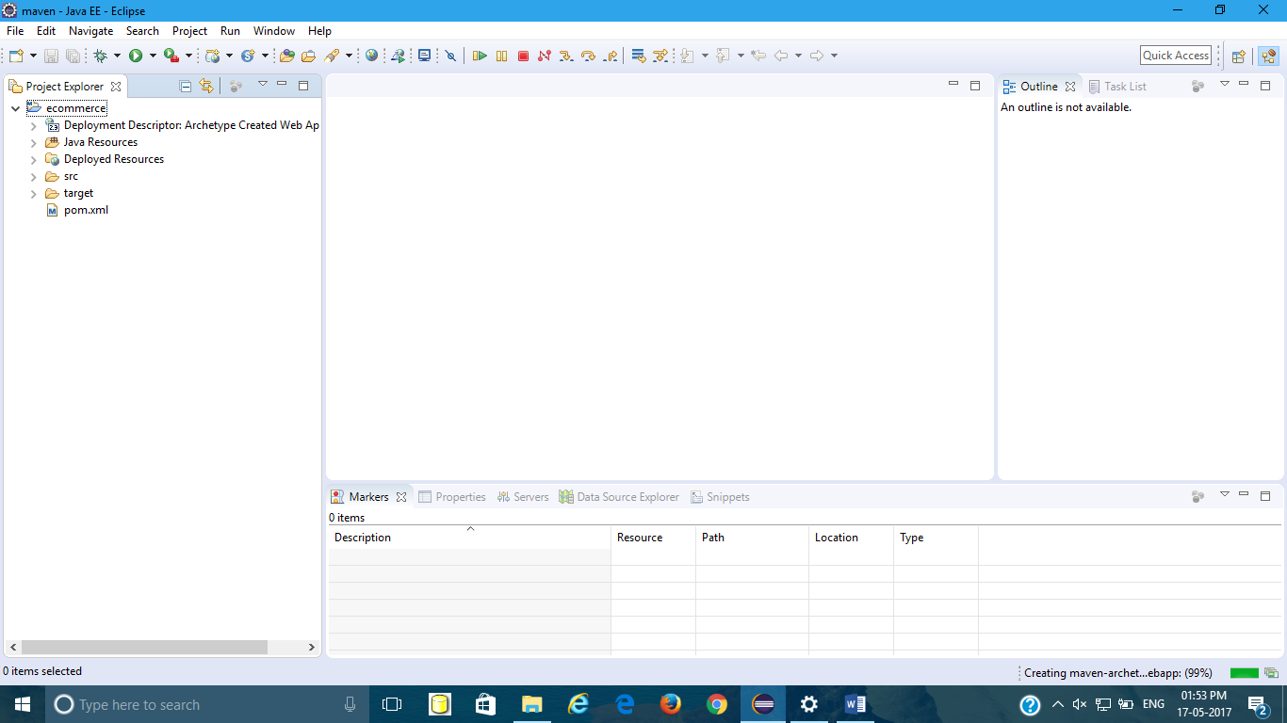

7.Adding tomcat server to project

Windows🡪preferences🡪server🡪Runtime Environment🡪Add🡪Apache tomcat 8🡪Next🡪browse tomcat folder🡪Finish

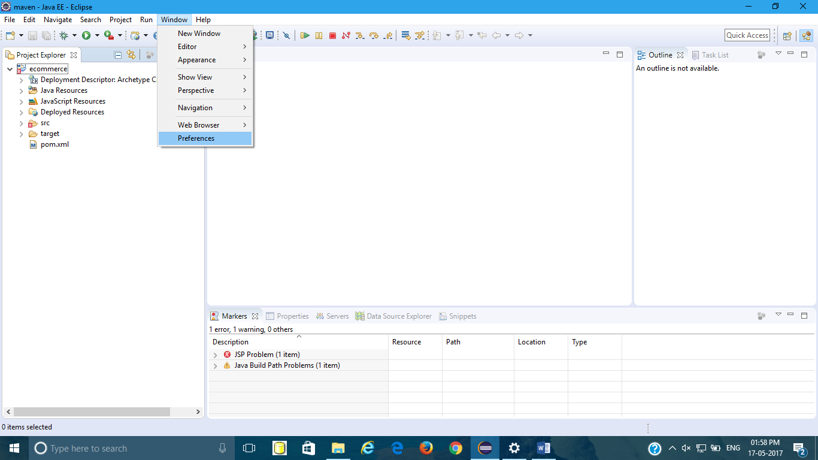

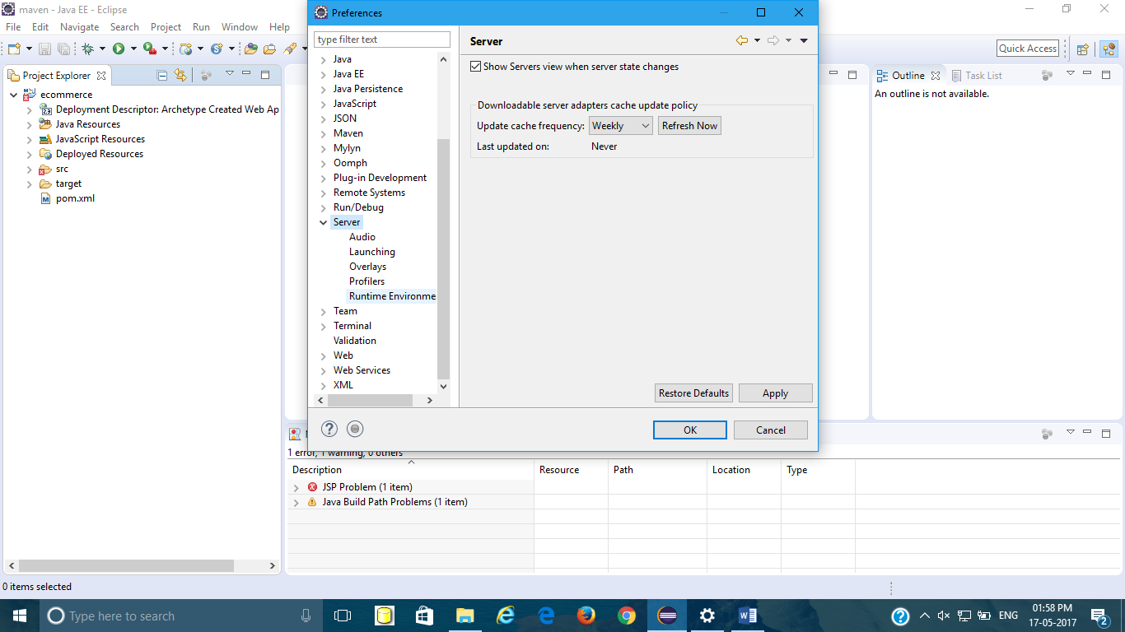

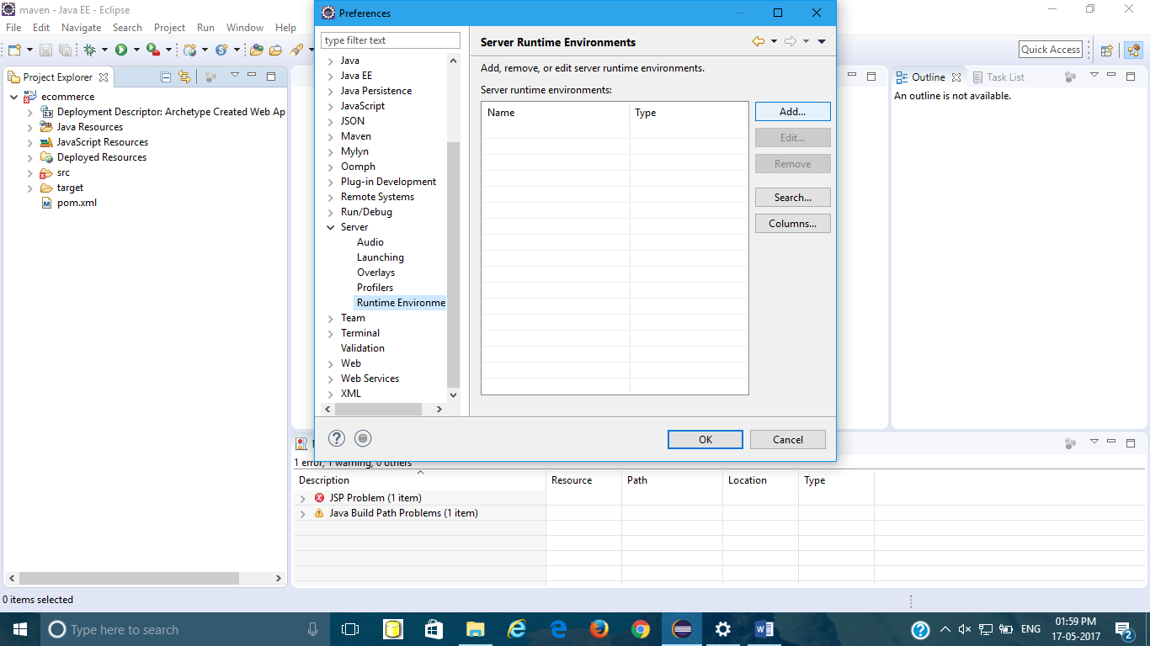

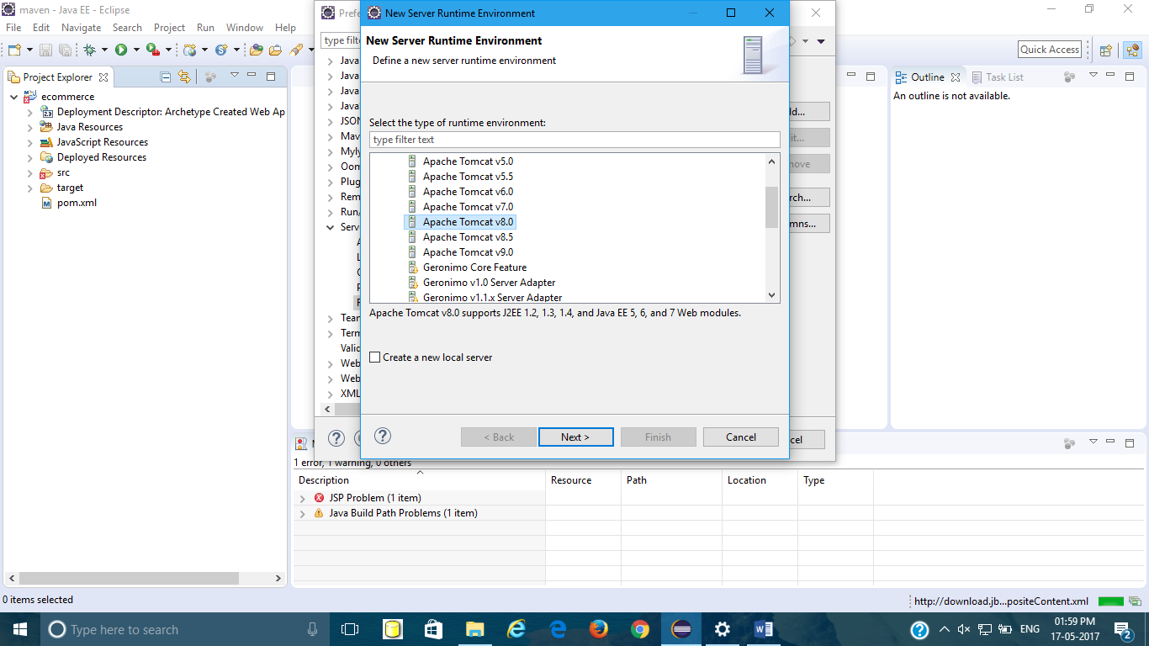

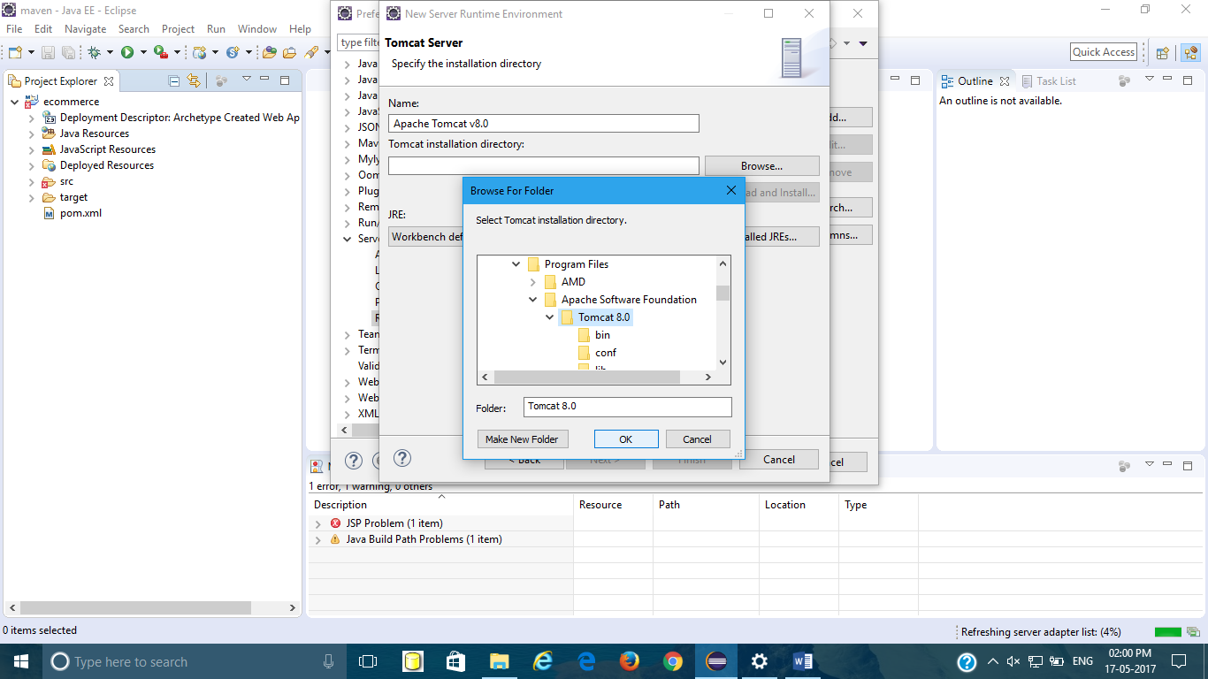

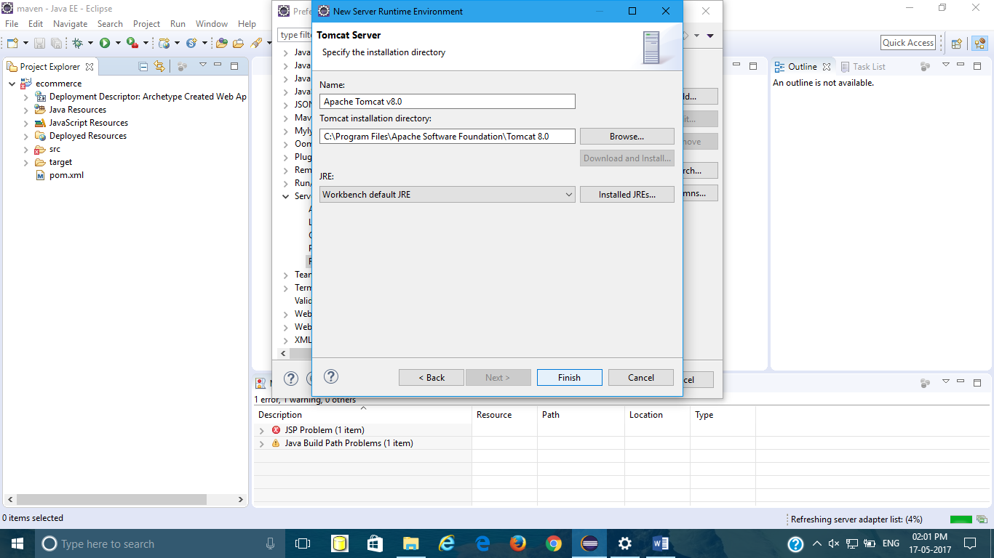

Add server as shown🡪click this to create a new server🡪tomcat8🡪Finish

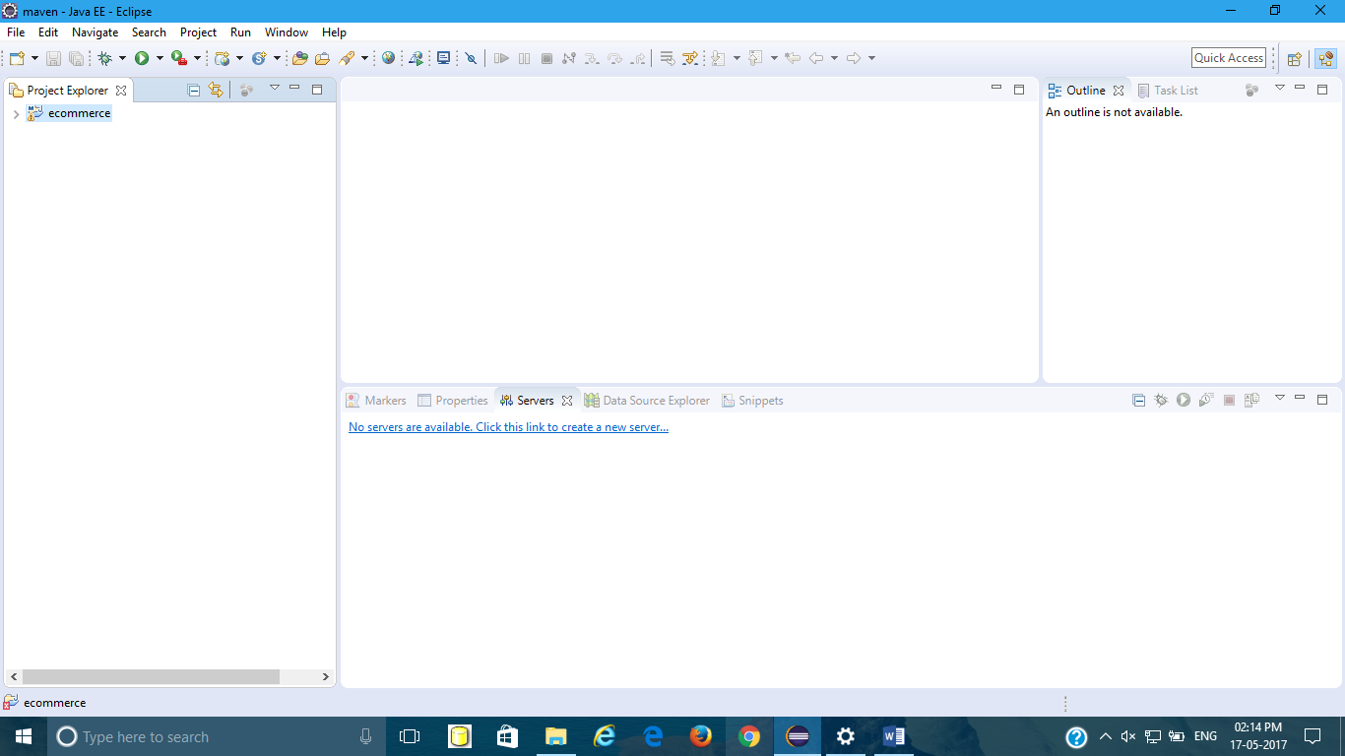

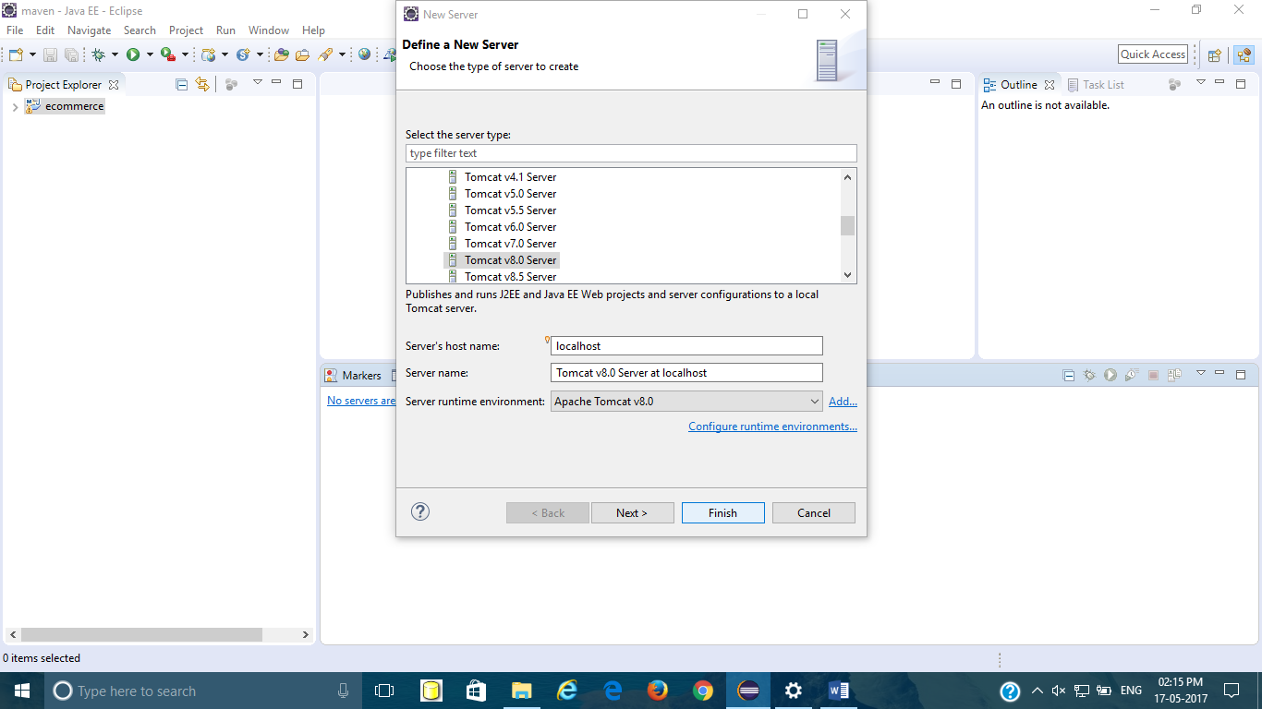

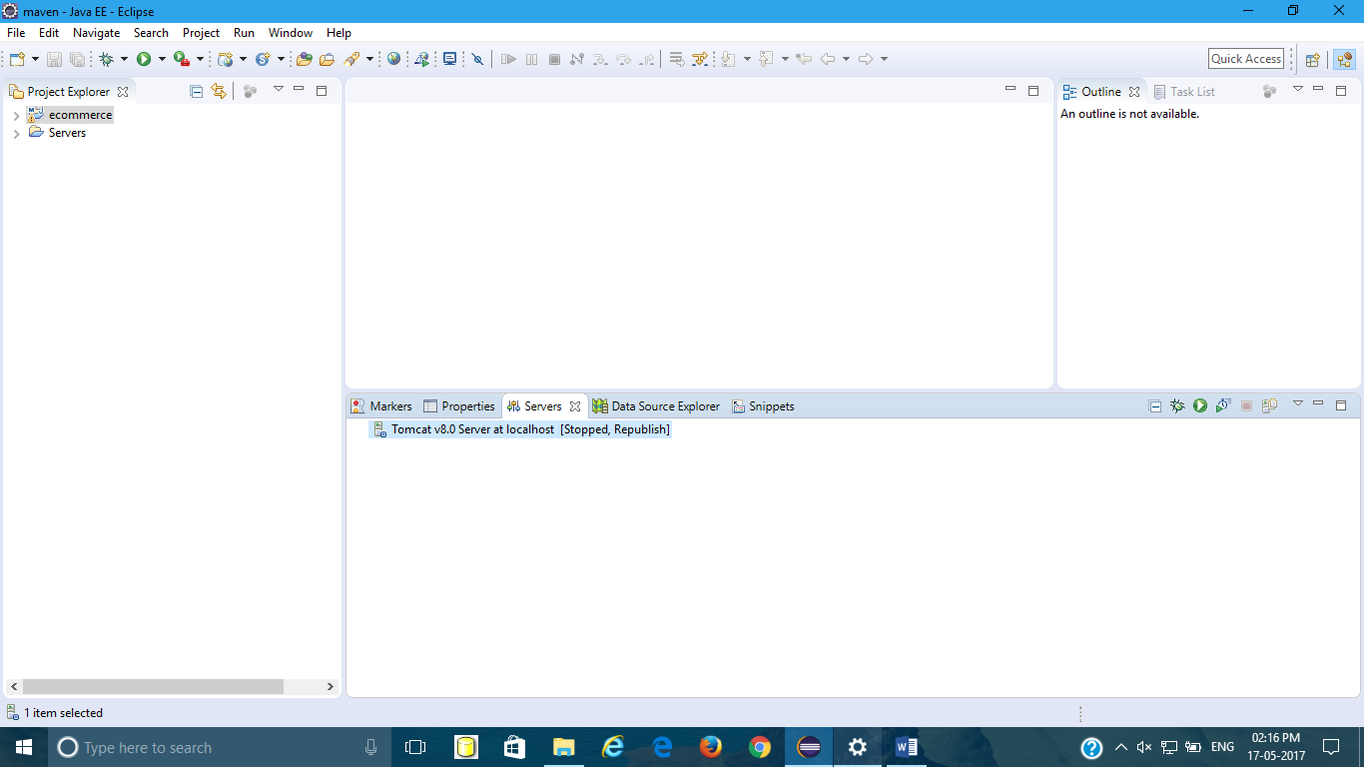

8.Adding path to JDK

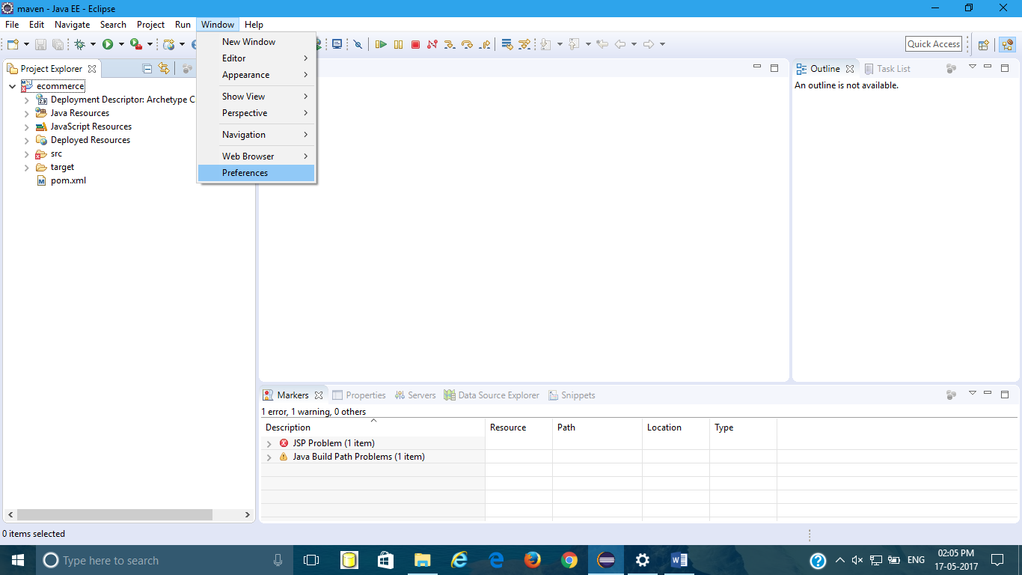

Preferences🡪Java🡪Installed JREs🡪Double click on Shown Part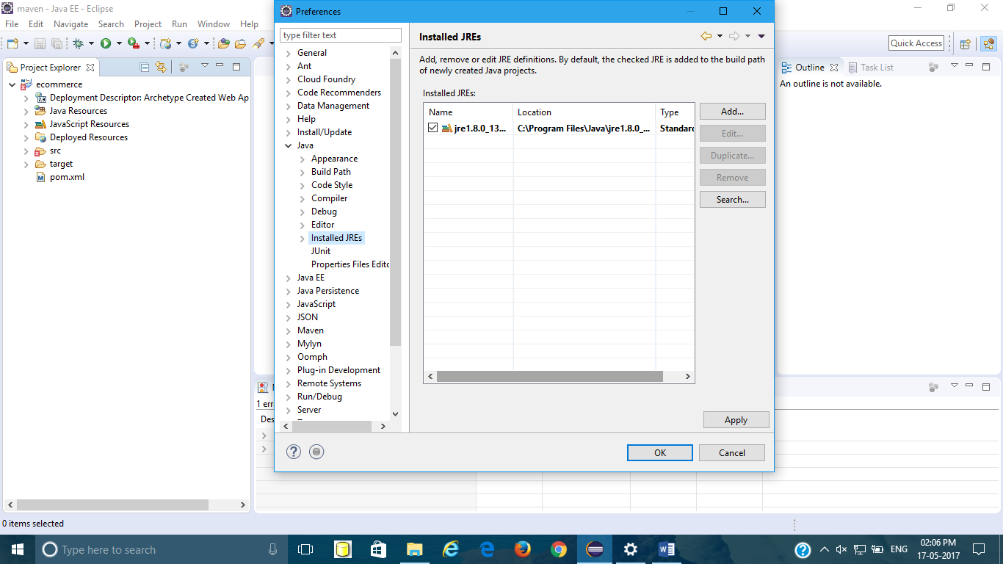

Directory🡪Browse your jdk folder🡪finish🡪Apply🡪Ok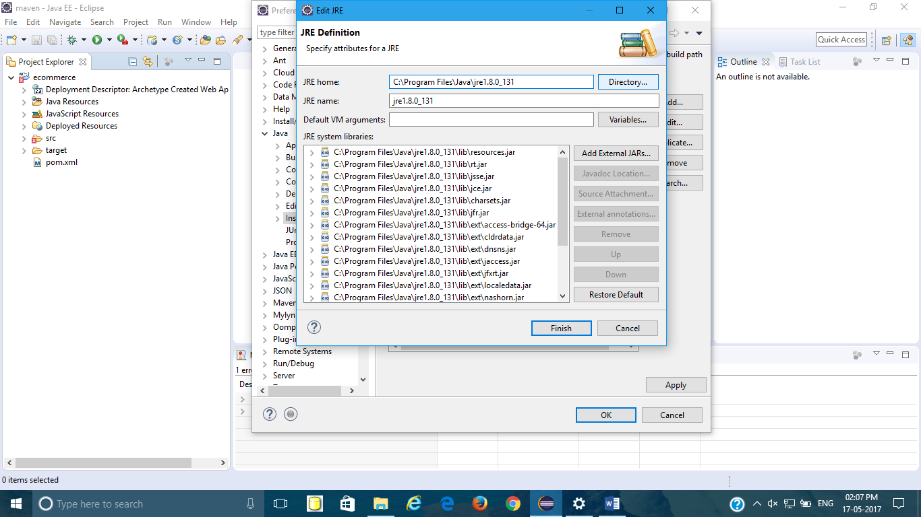

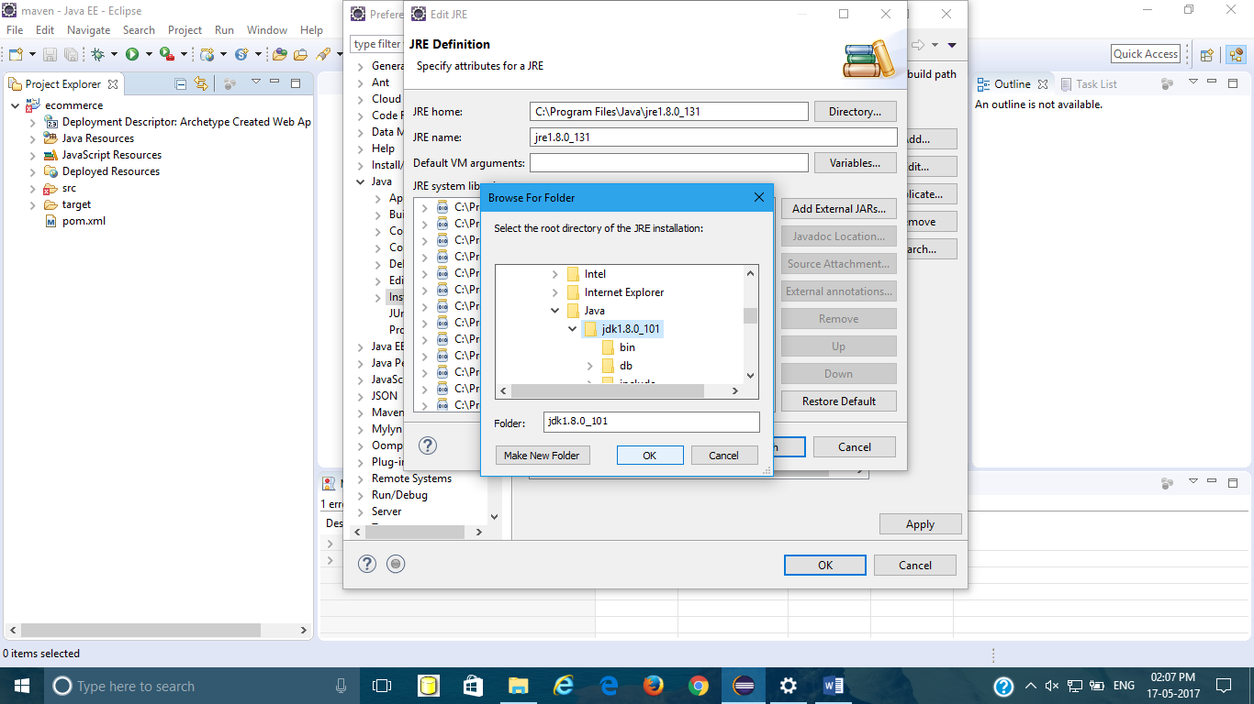

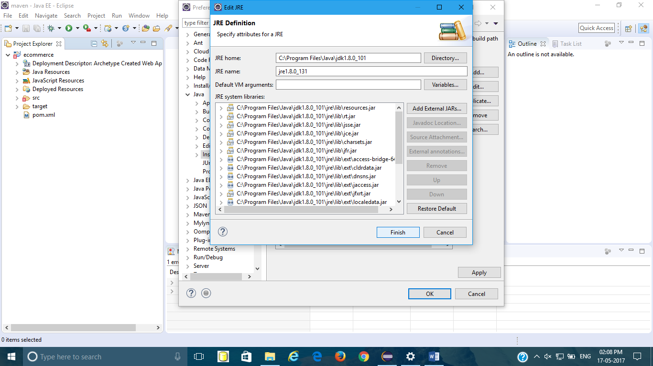

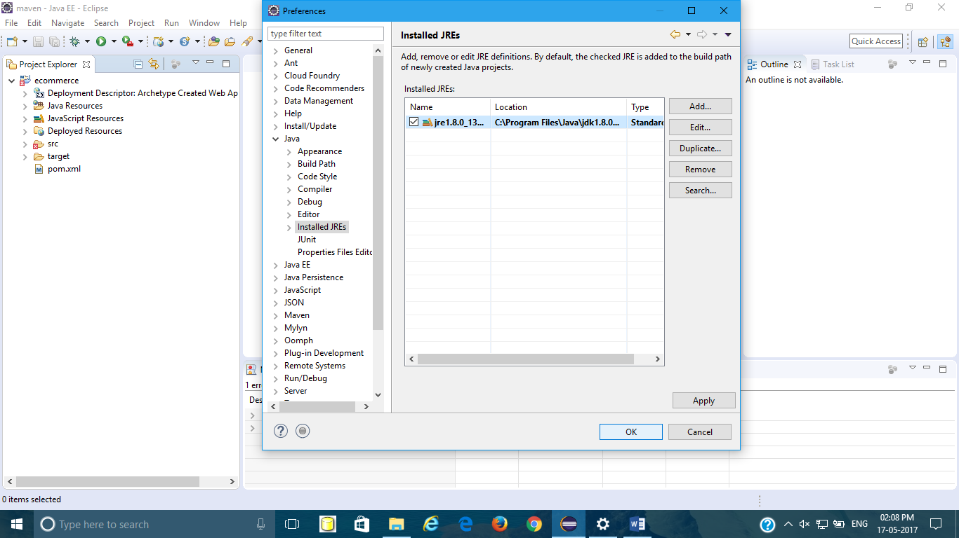

9.Inorder to rectify following Error

Description Resource Path Location Type

The superclass "javax.servlet.http.HttpServlet" was not found on the Java Build Path index.jsp /ecommerce/src/main/webapp line 1 JSP Problem

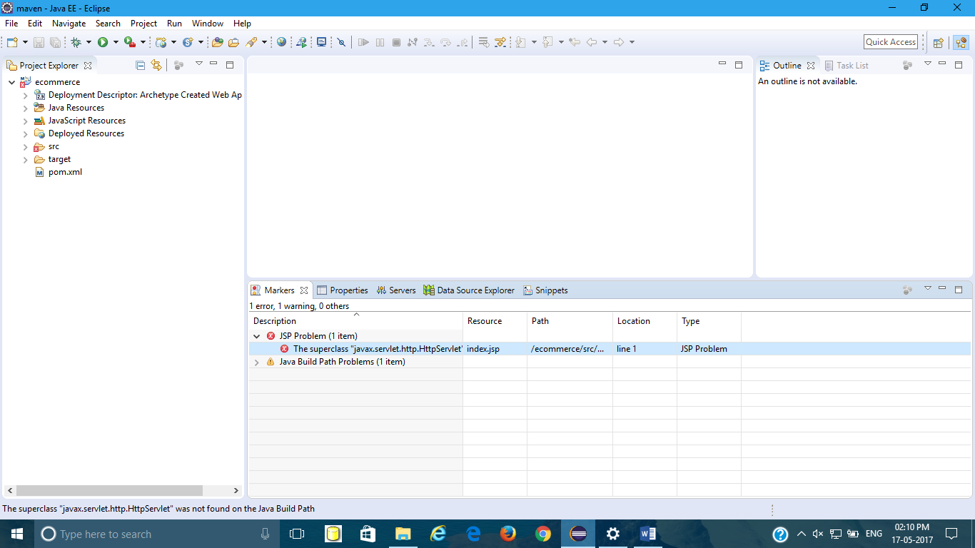

Do following Steps

Right click on project🡪Build Path🡪configure Build Path🡪Add Library🡪Server runtime🡪Select Apache tomcat8🡪Finish.

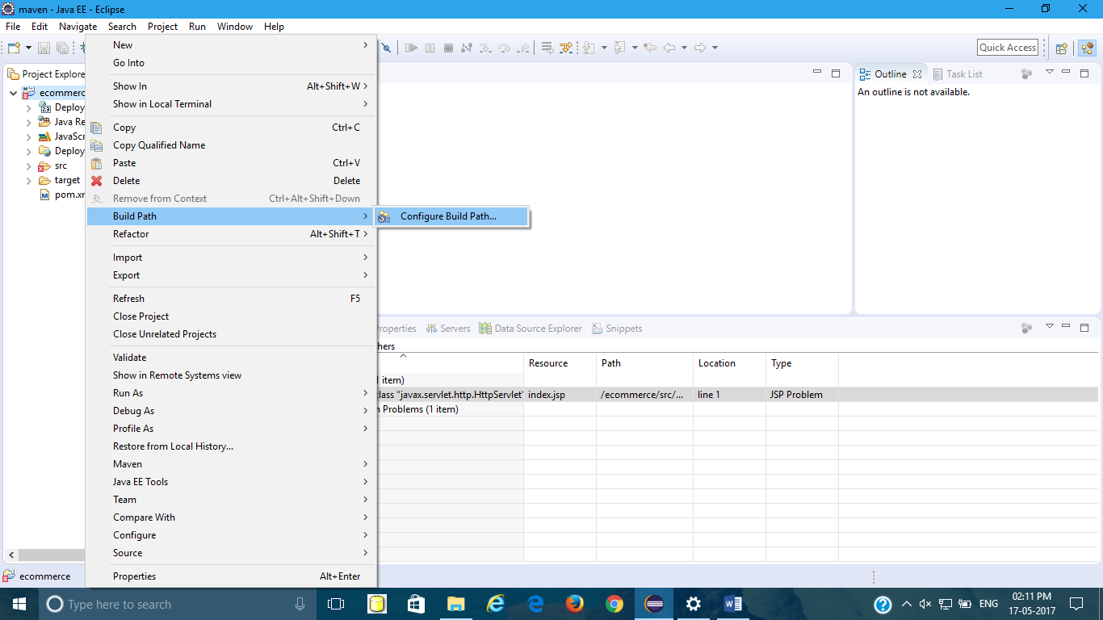

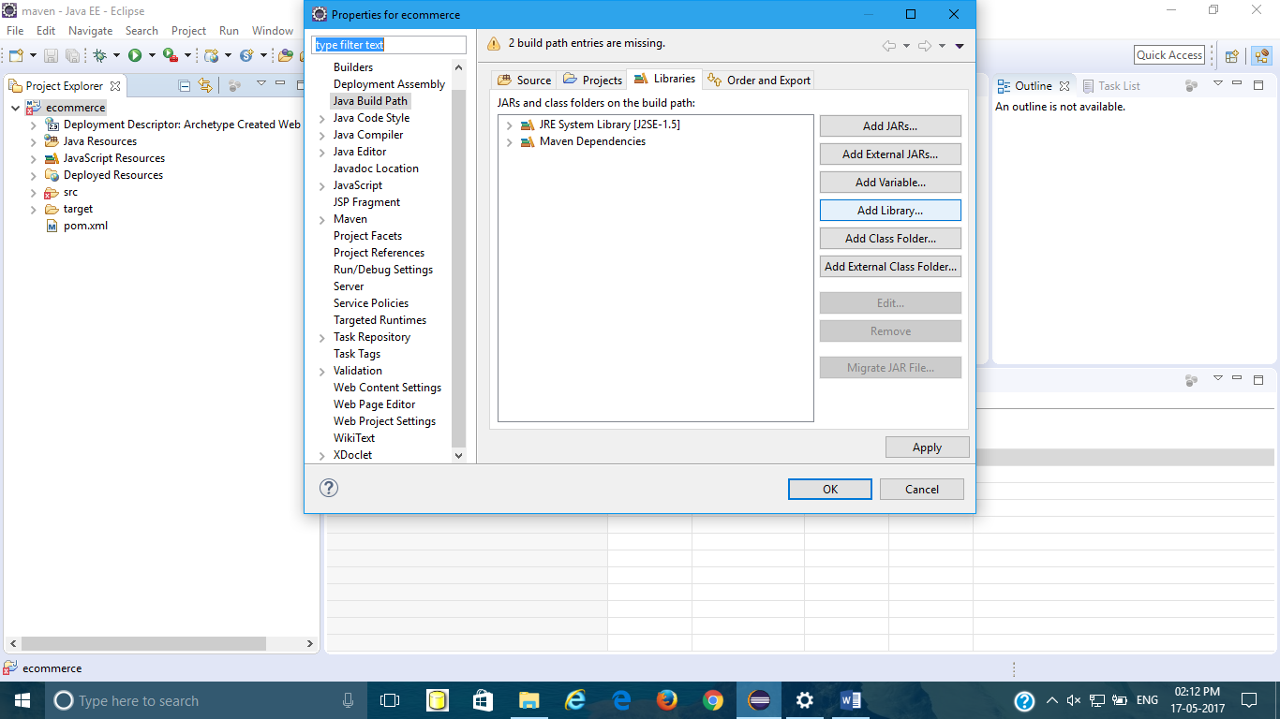

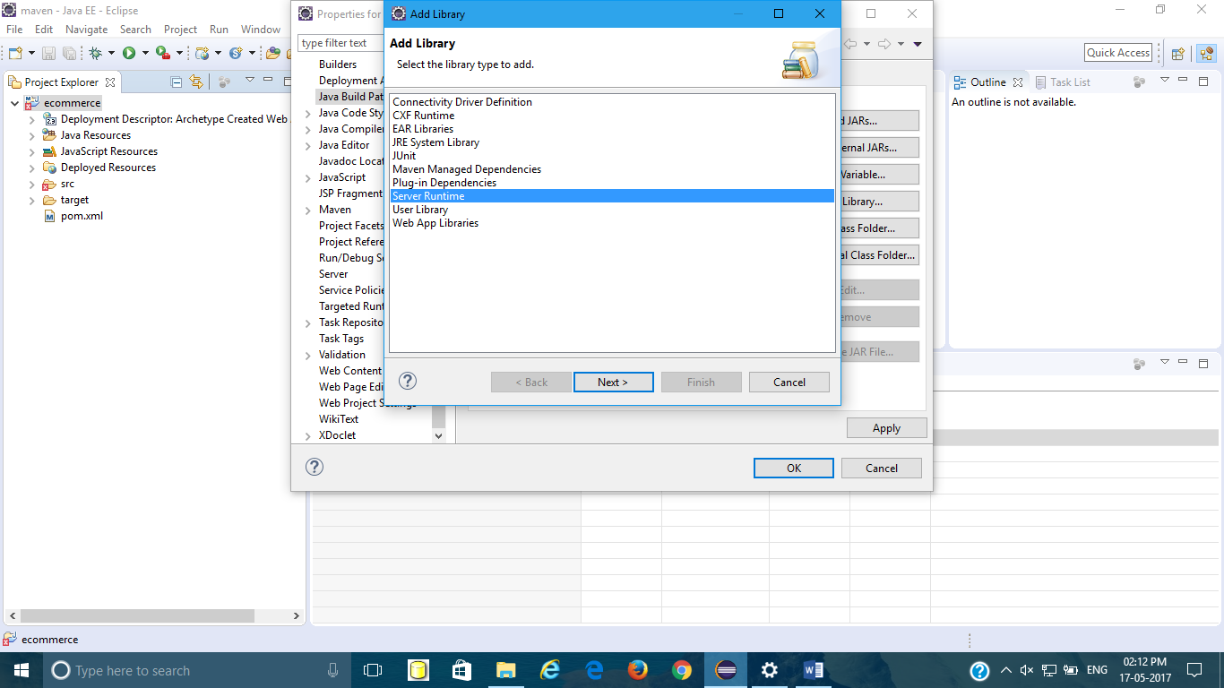

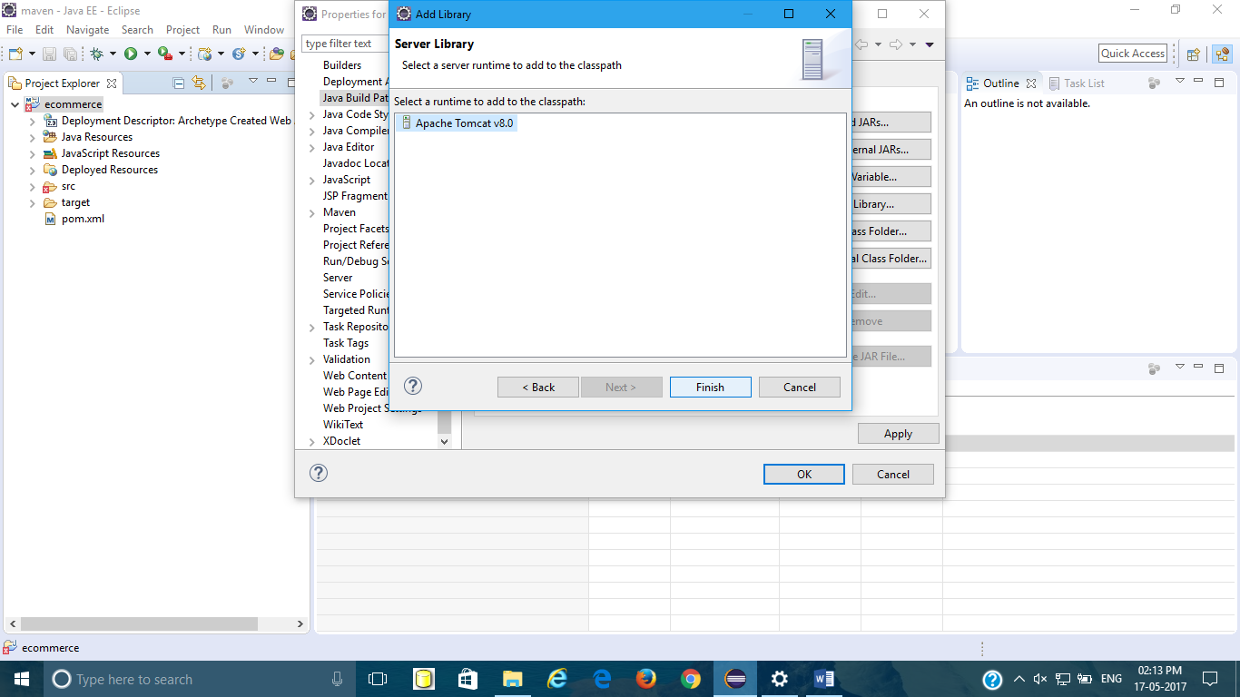

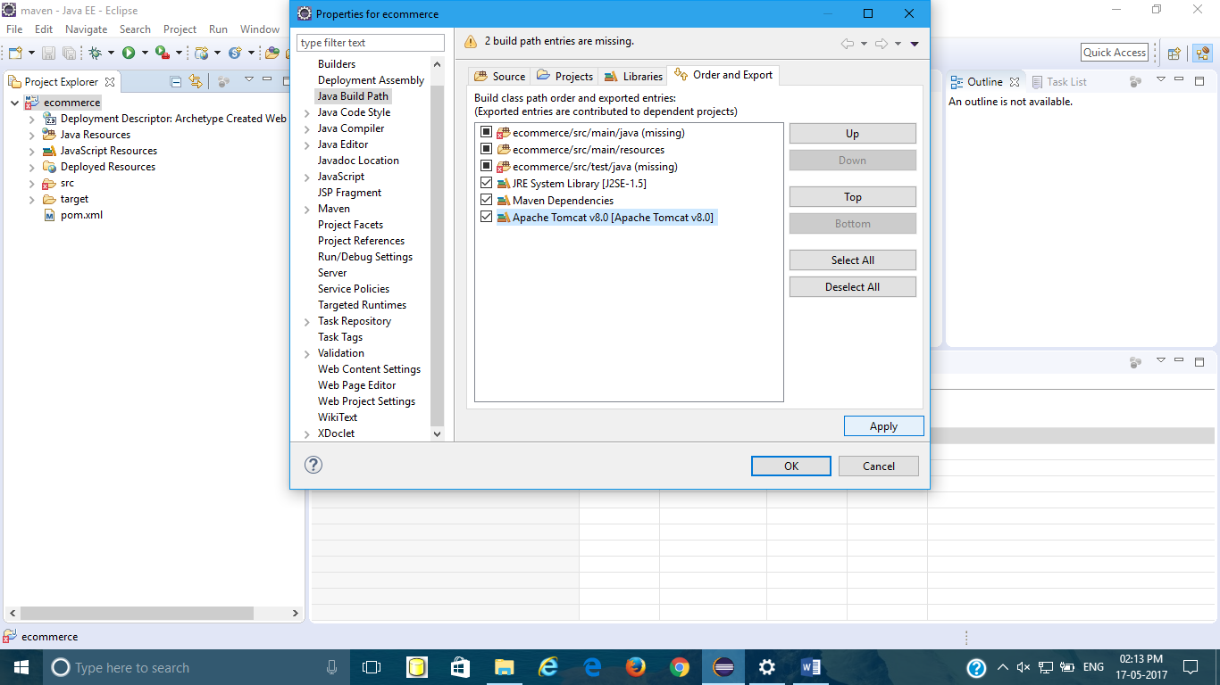

10.Configure project facets🡪Right click on project🡪properties🡪project facet🡪java 1.8🡪apply🡪Finish

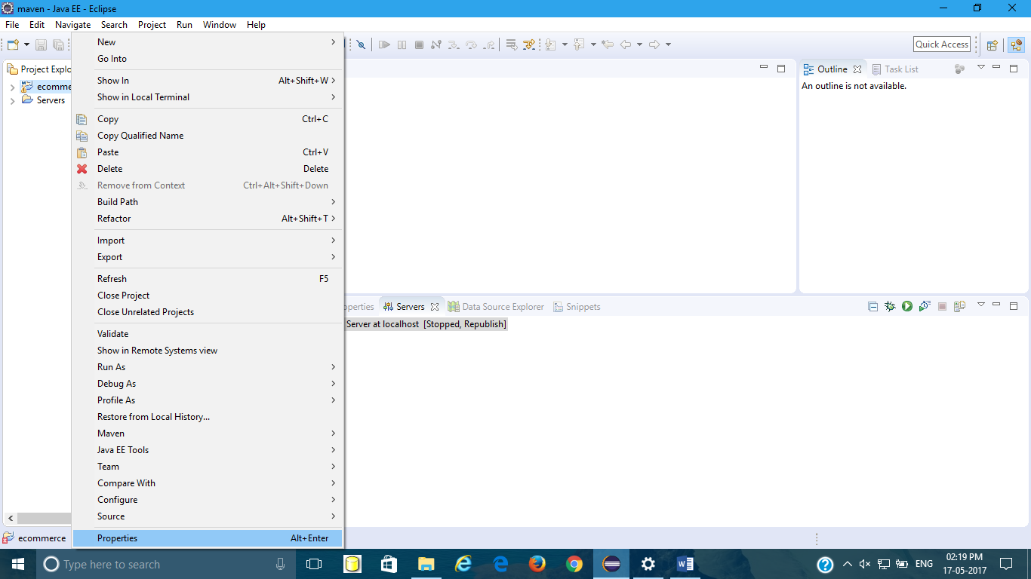

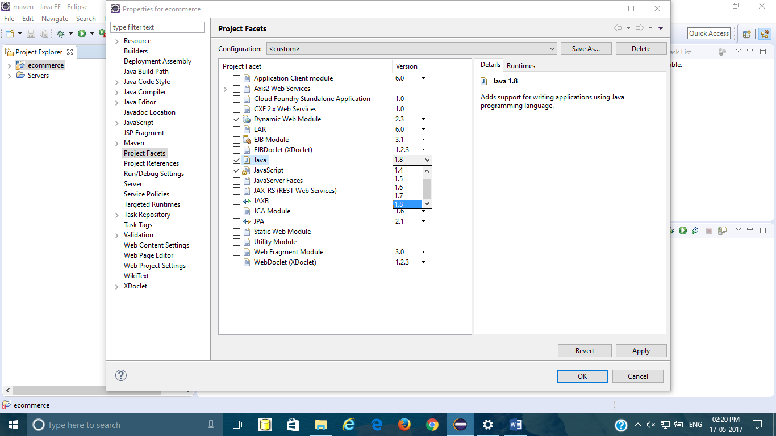

Here we are completed with our project configuration.

11.Create resources and pages folder under WEB-INF folder and under resources create images and css folder.

src🡪main🡪webapp🡪WEB-INF🡪resourses

src🡪main🡪webapp🡪WEB-INF🡪pages

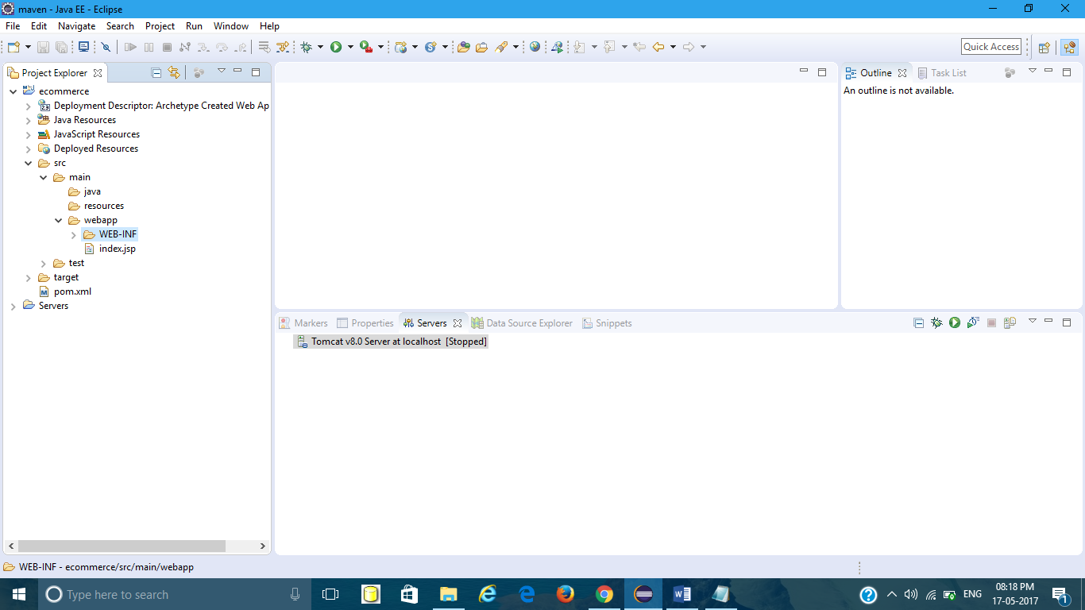

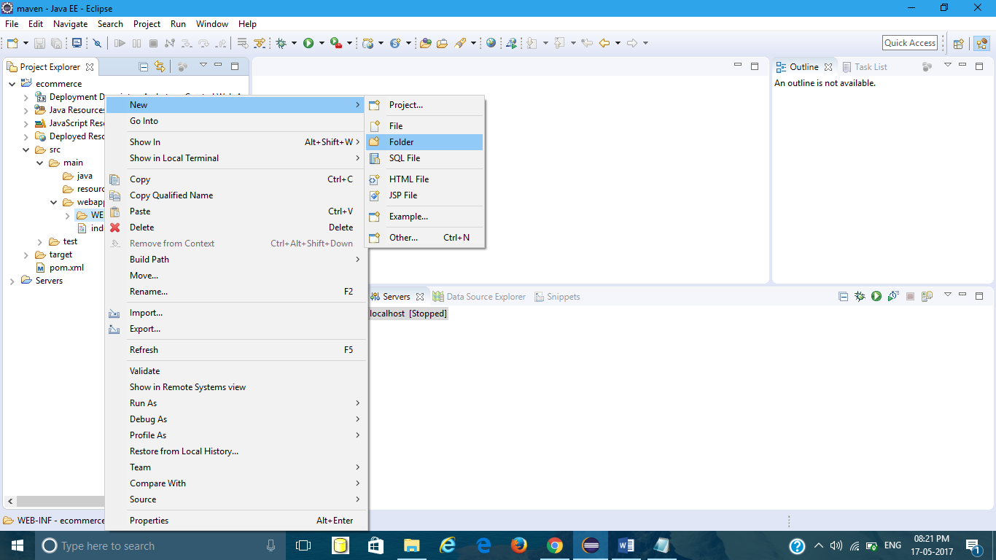

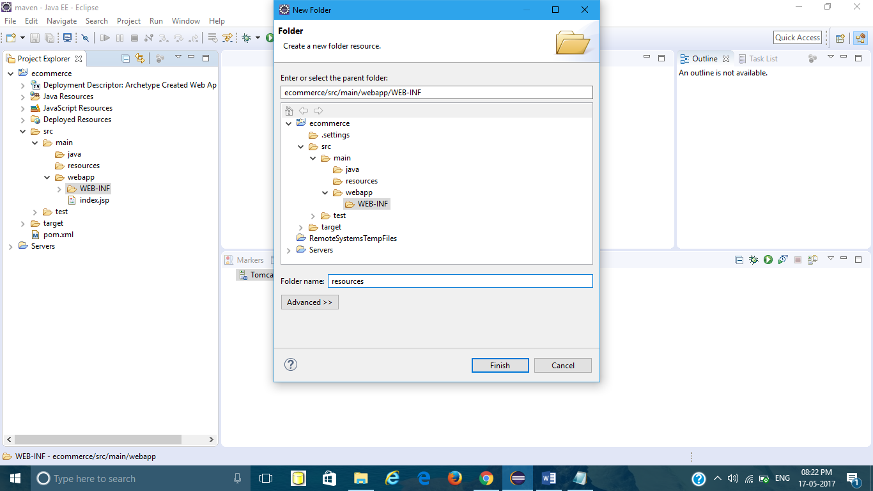

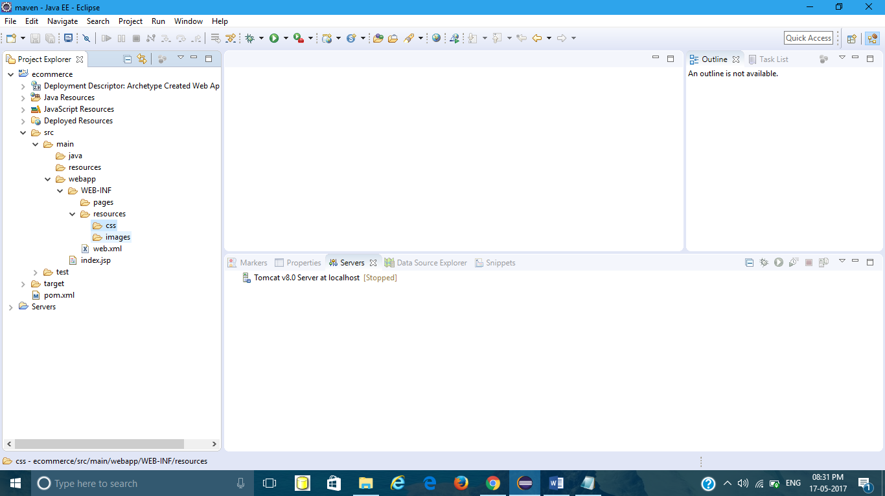

Under pages folder create required jsp/html pages and add required images under images folder.

12.Creating First jsp page for my project(home).

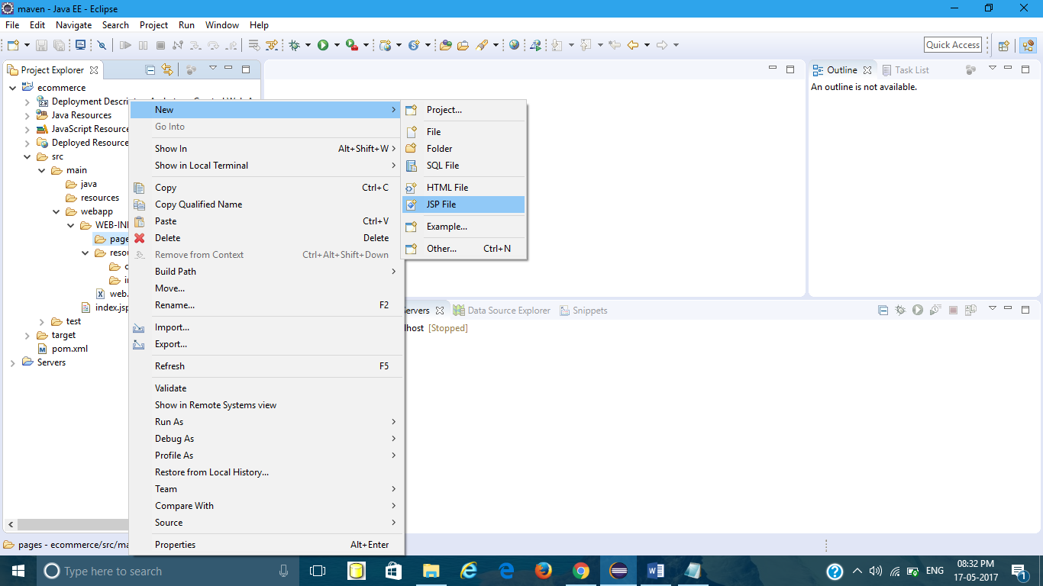

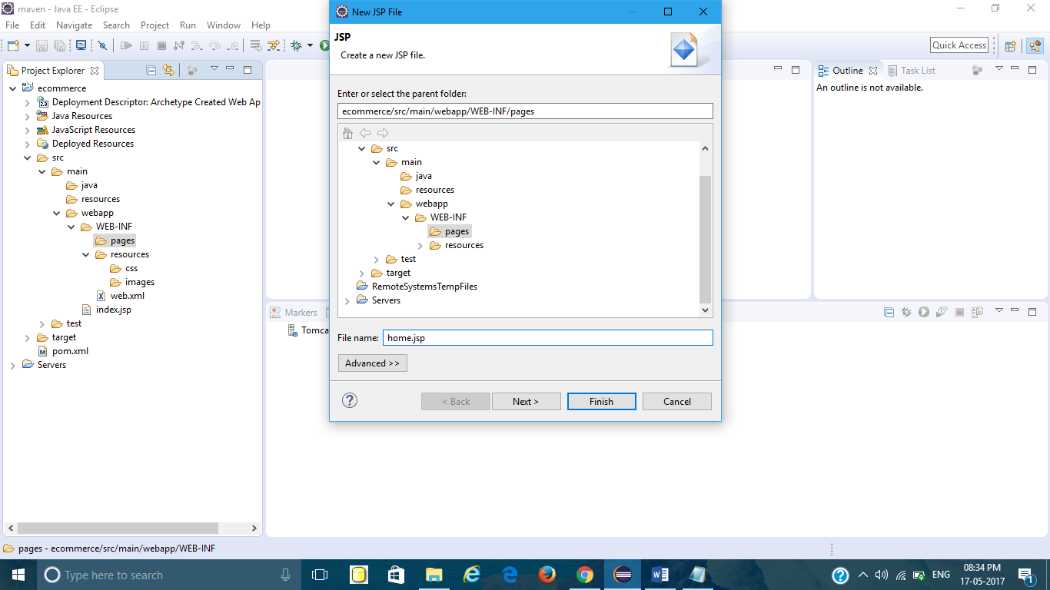

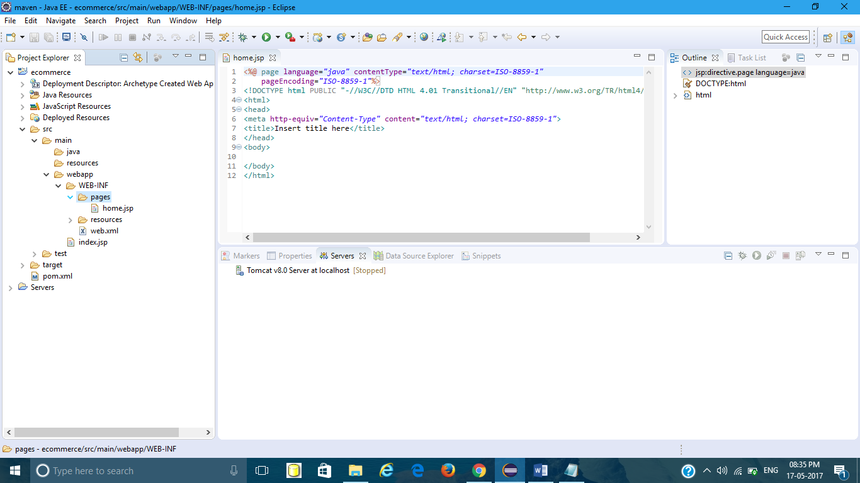

Same way add required jsp pages for your project. 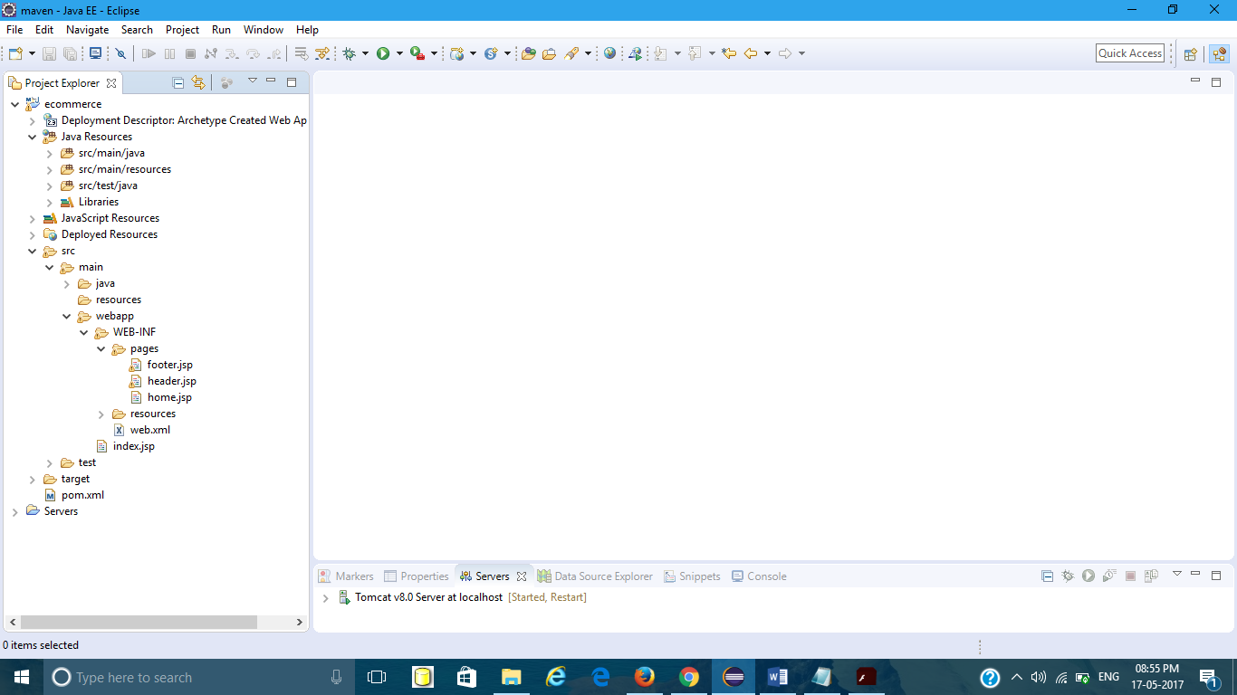

13.Adding dependencies in pom.xml file. 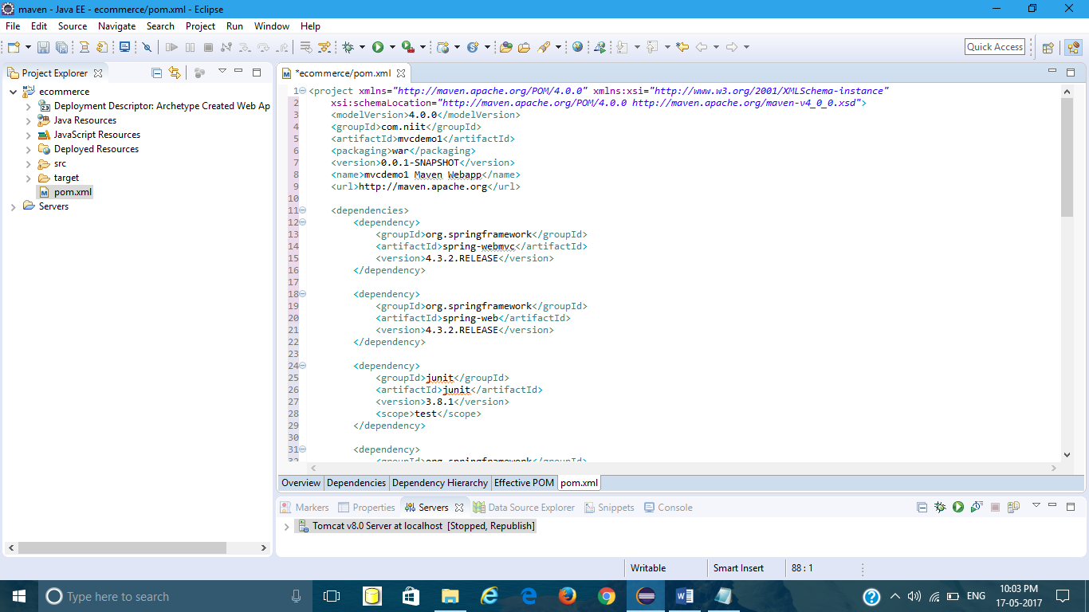

14.updating Web.xml

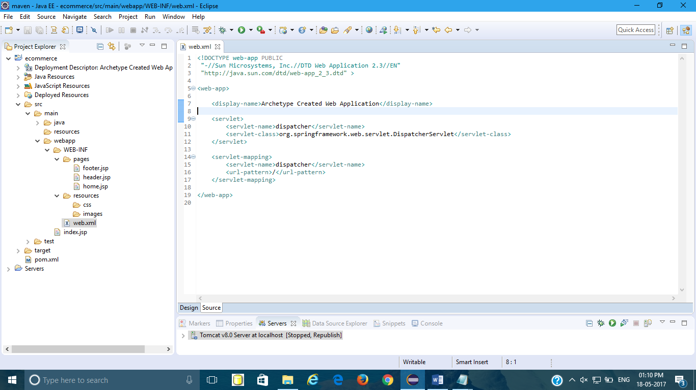

Create instance for Dispatcher Servlet and it will initialize it.  
3. servlet mapping URL pattern - / [any request - forwarded to DispatcherServlet]  
4. it will search for a file named dispatcher-servlet.xml

15.Create dispatcher-servlet.xml under WEB-INF as shown

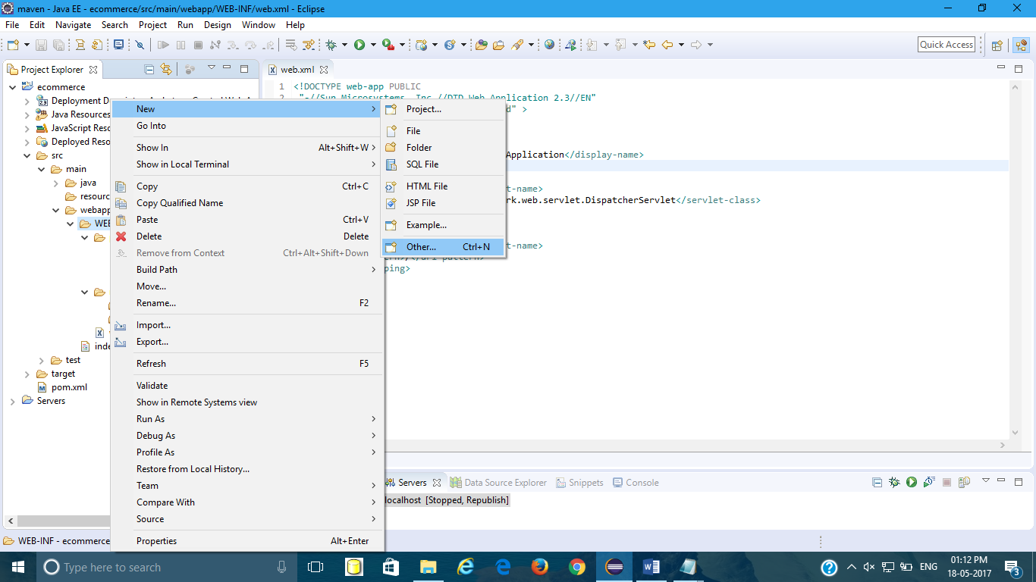

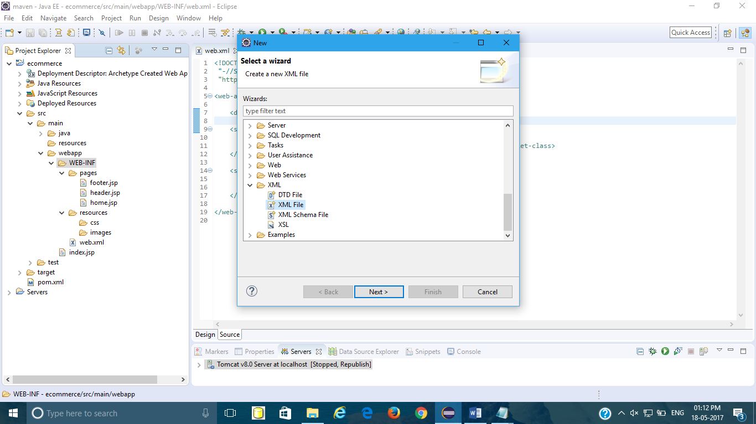

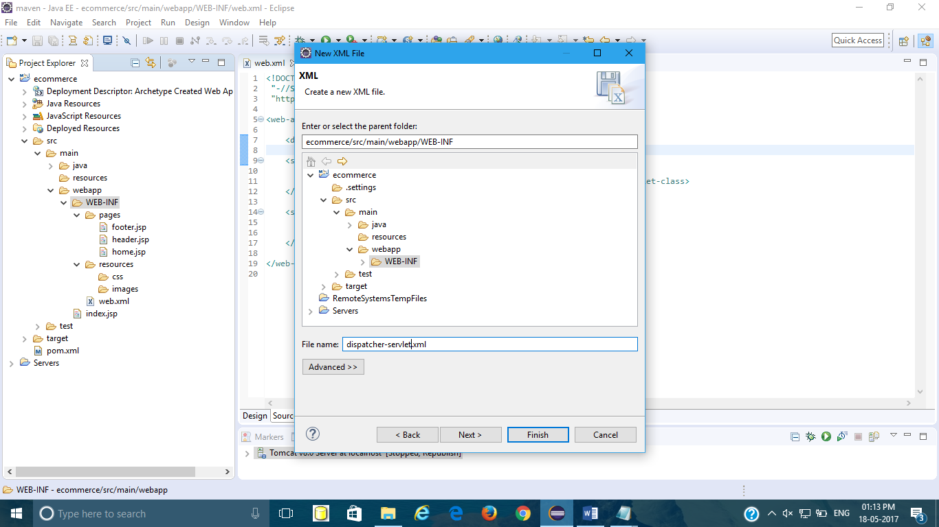

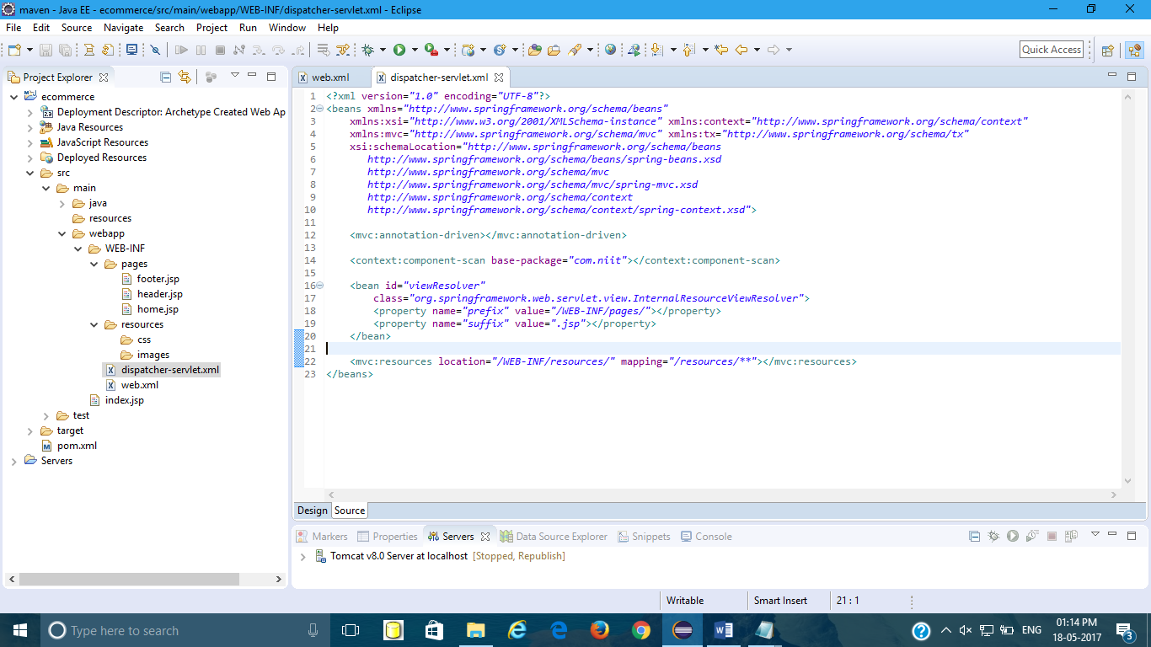

a. enabled spring mvc <mvc:annotation-driven]  
b. Scan all the classes in the package com.niit  
HomeController , it will get instantiated/ [create a bean]  
c. DispatcherServlet create HandlerMapping , using @RequestMapping annotation  
/home homeController.getHomePage()  
d. create a bean for InternalResourceViewResolver   
[InternalResourceViewResolver viewResolver=new InternalResourceViewResolver()  
logical view name to actual view name  
add a prefix /WEB-INF/pages/  
add a suffix .jsp  
viewResolver.setPrefix("/WEB-INF/pages/")  
viewResolver.setSuffix(".jsp")

12.Create new package under src/main/java as com.niit.controllers

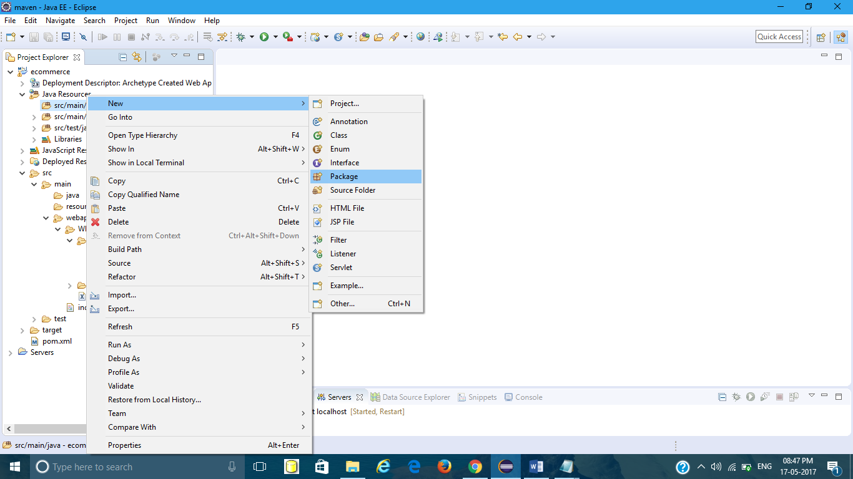

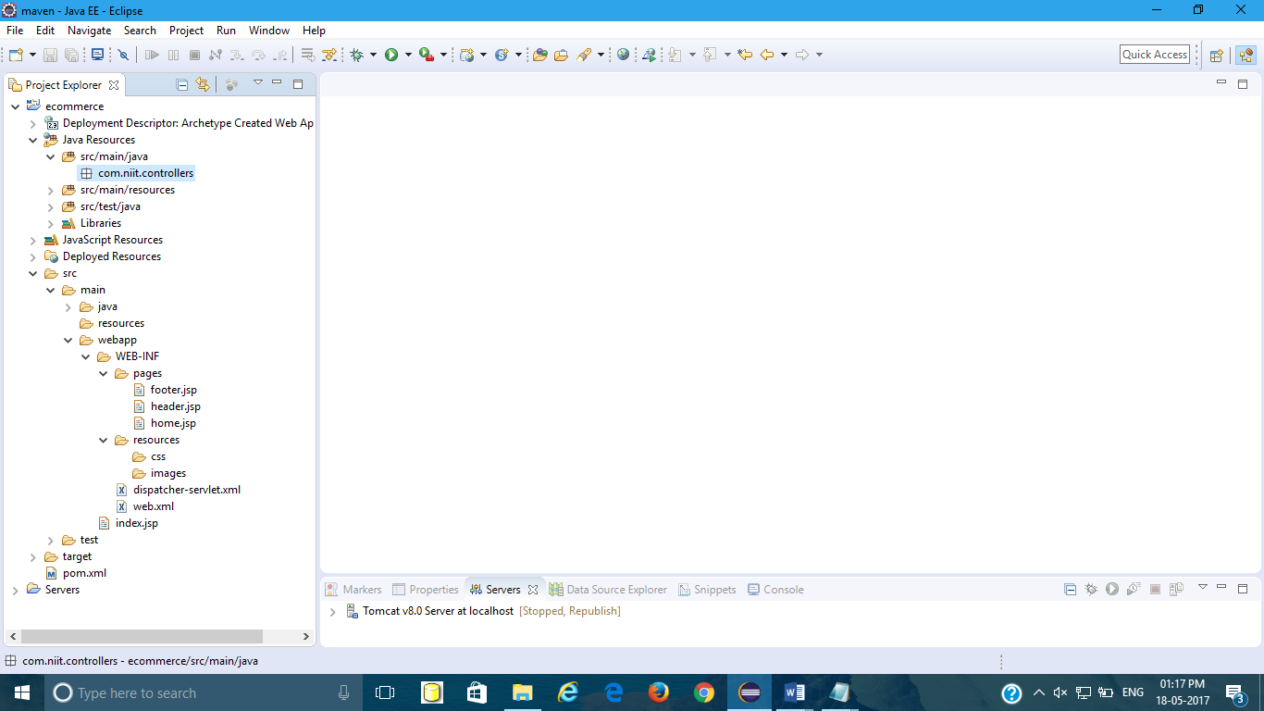

Under com.niit.controller create class HomeController.

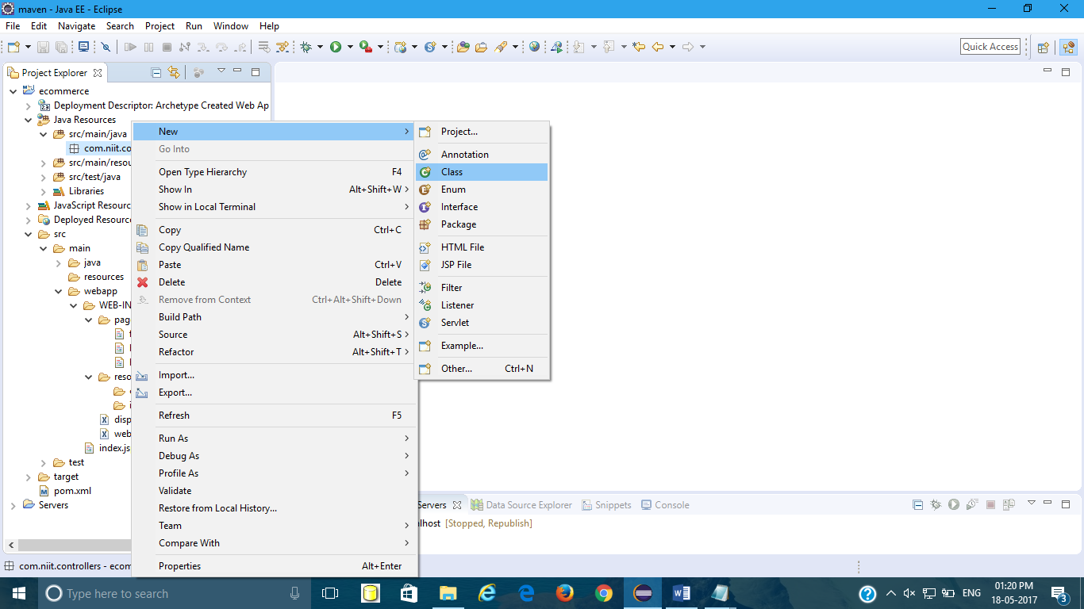

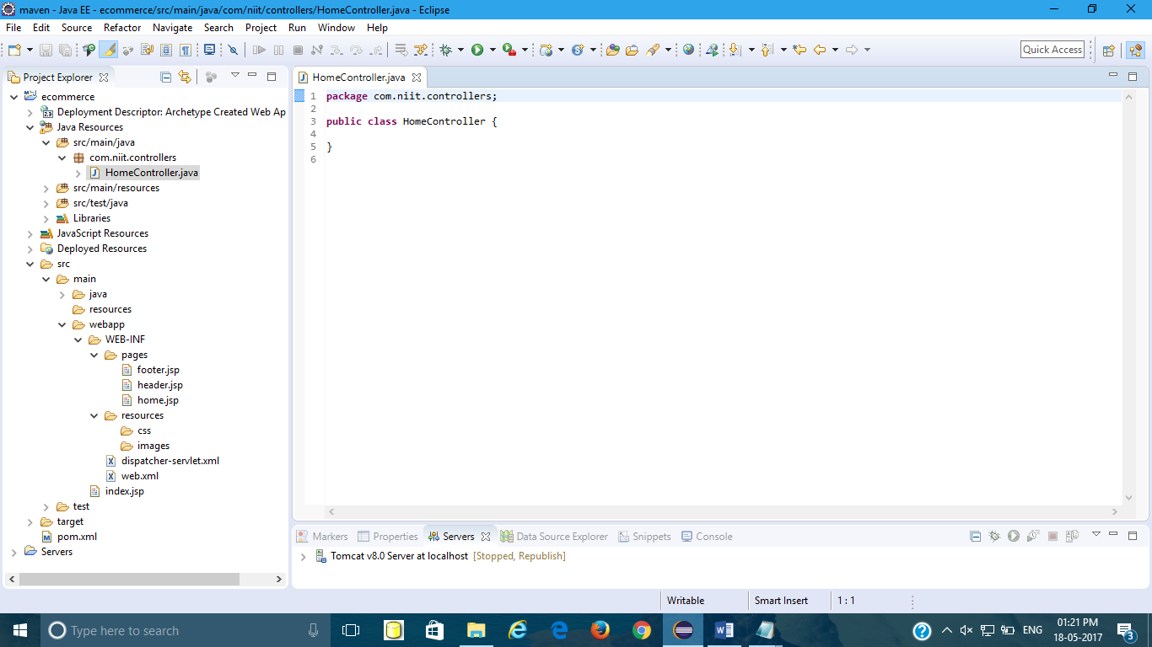

Write controller/ url handler method as shown

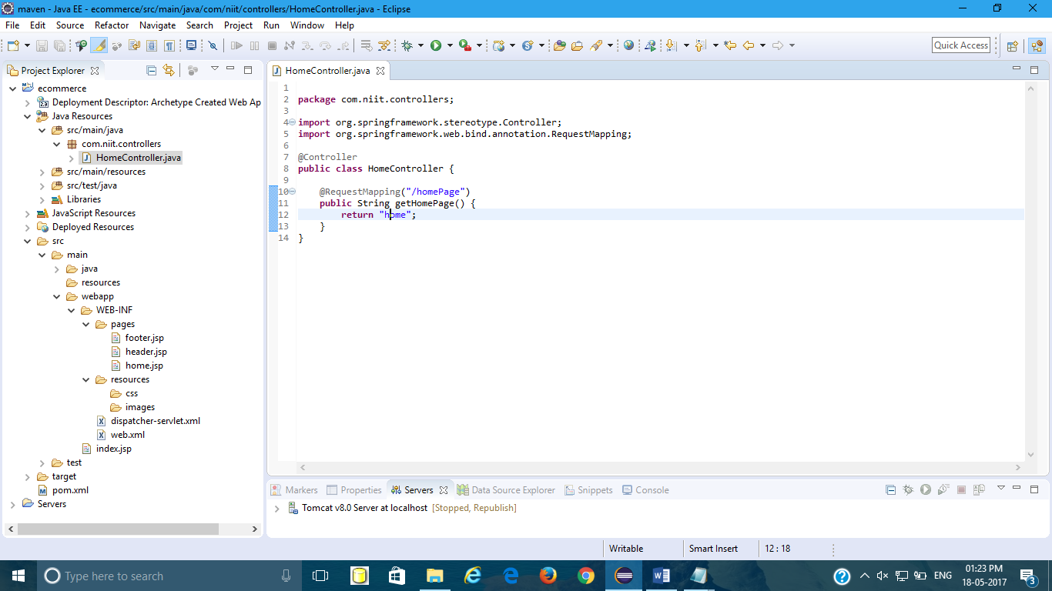

13.Now run your project on tomcat server to see your [home.jsp.Right](http://home.jsp.Right) click on your project🡪run as🡪Run on server.

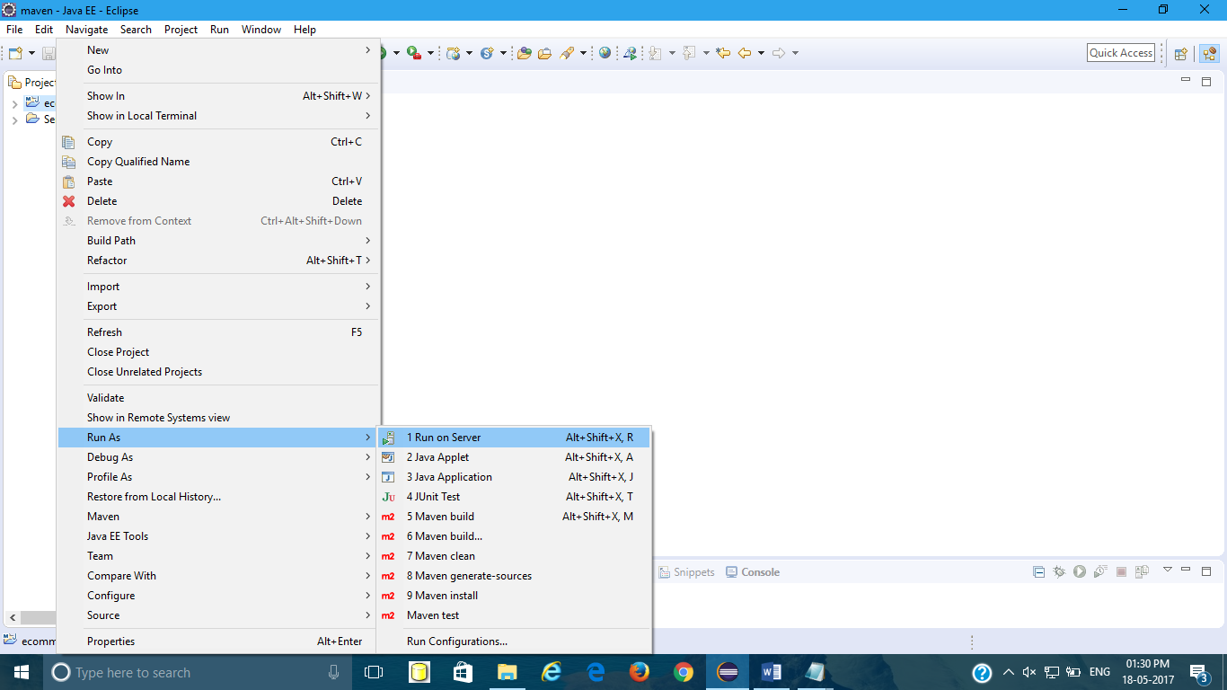

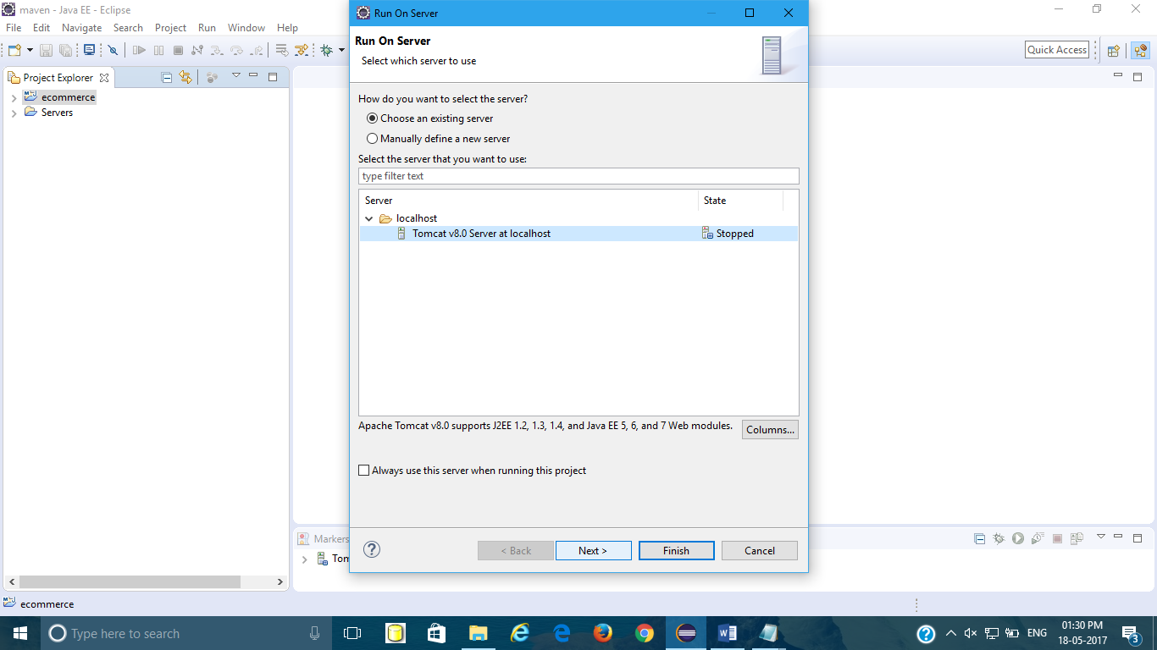

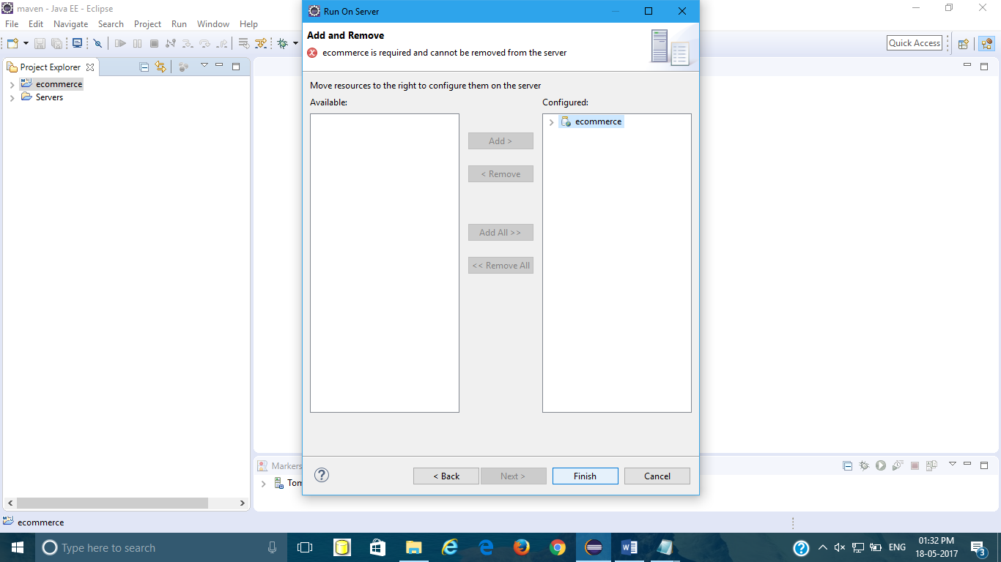

Now you will get index.jsp page as shown

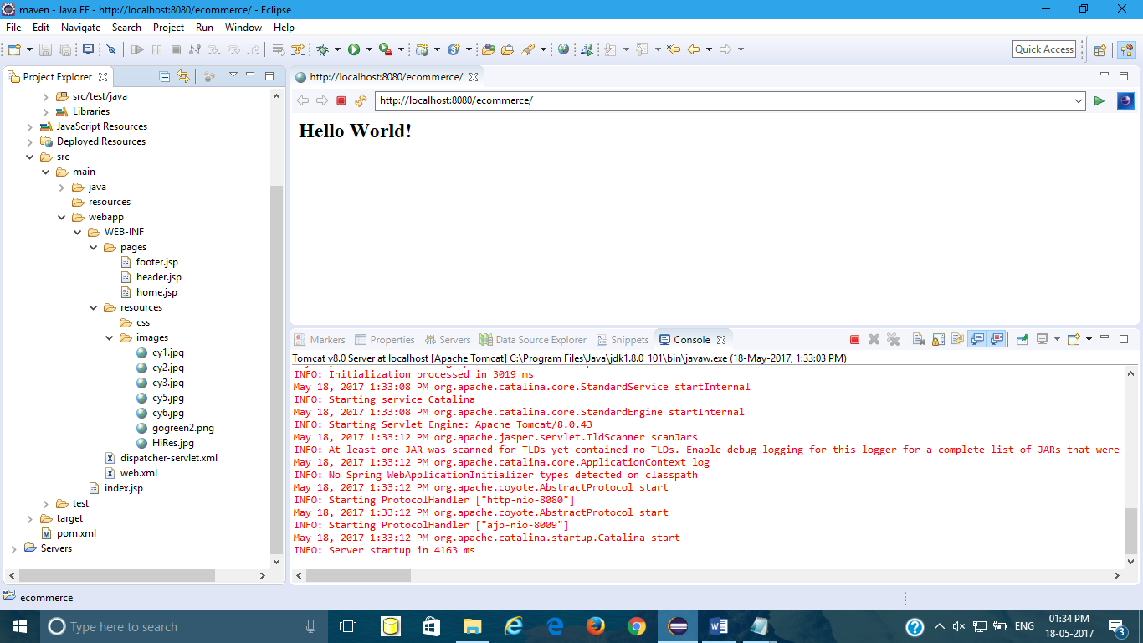

In order to get your home page write url as shown

<http://localhost:8080/ecommerce/homePage>

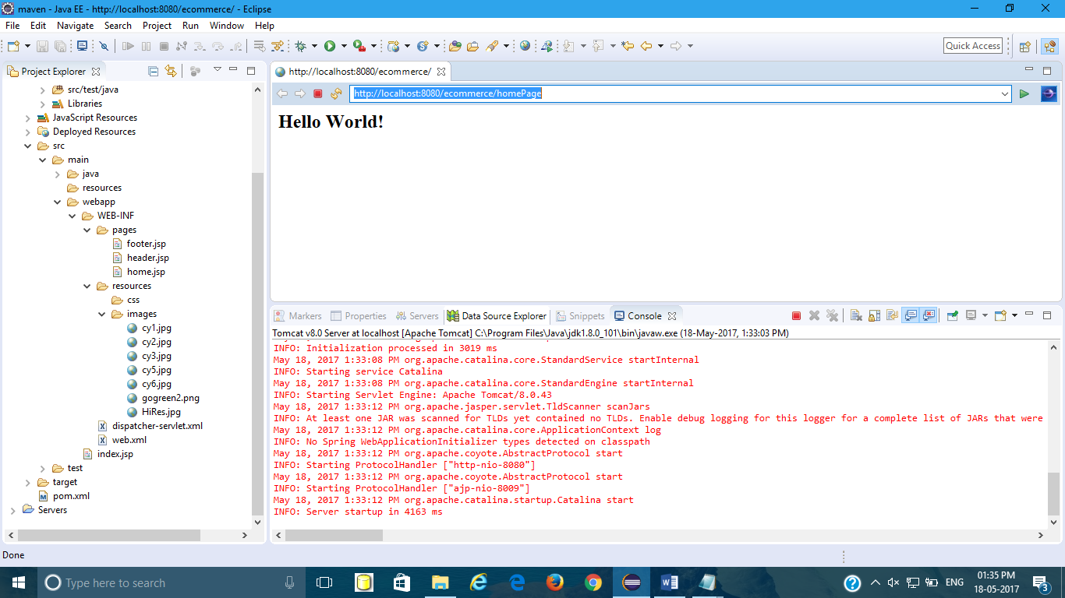

Now you will get your home page as shown

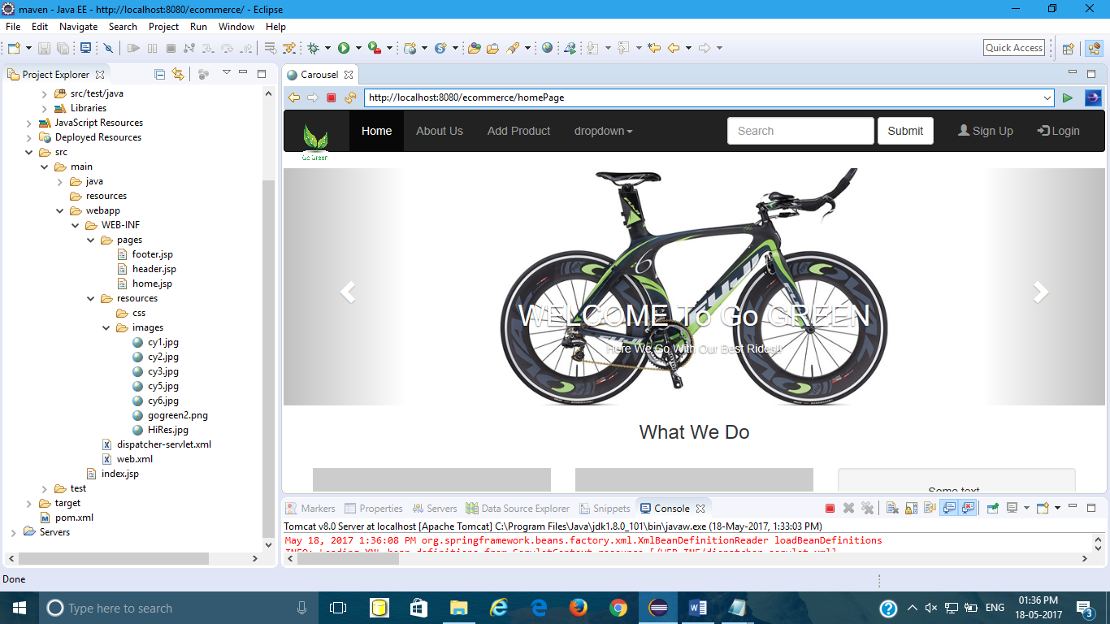

Also check your console to see mapping is correct or not as shown

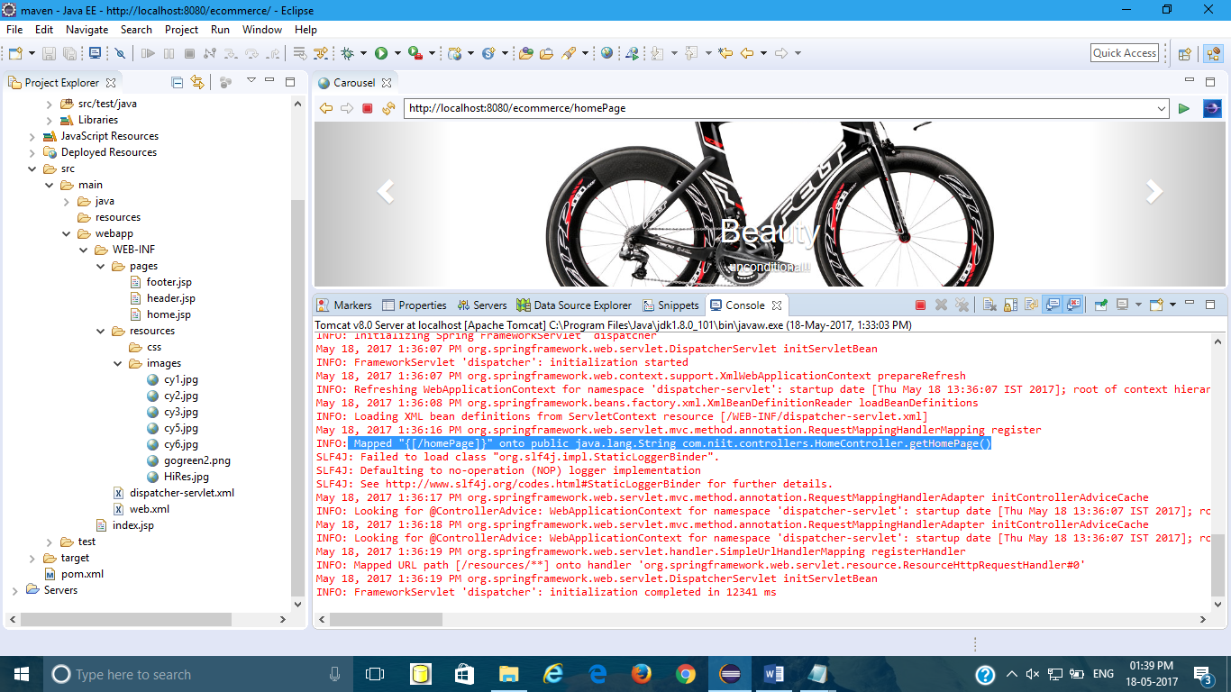

In this way you can make your first maven project.

14.Adding product form.jsp,view product.jsp and ProductController.java file

1.productform

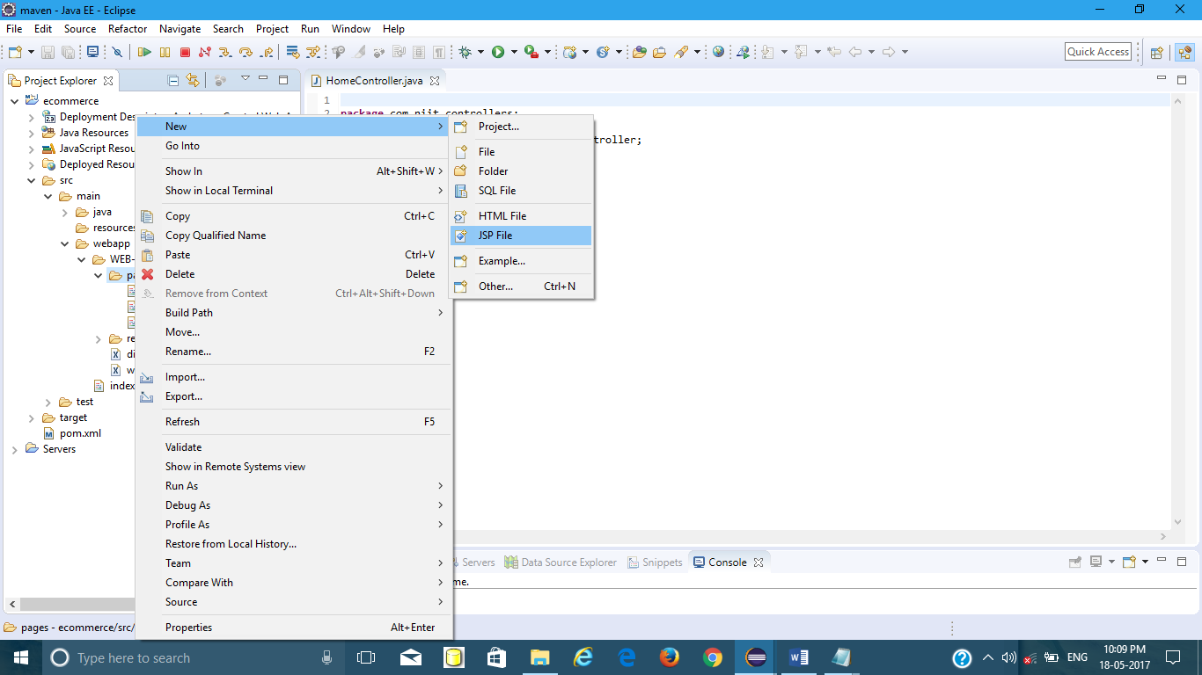

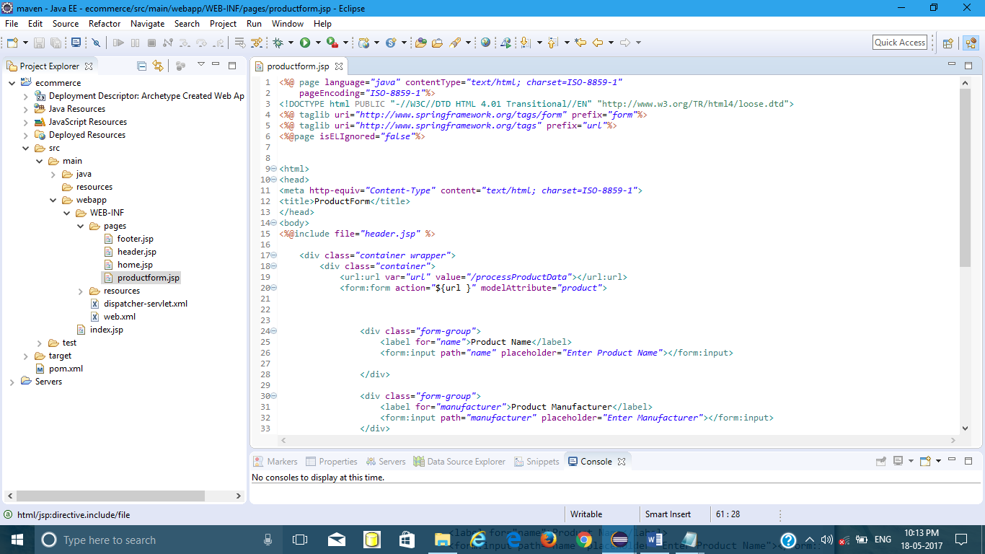

Create new package under src/main/java as com.niit.model.under this package create pojo class Product.java as shown.

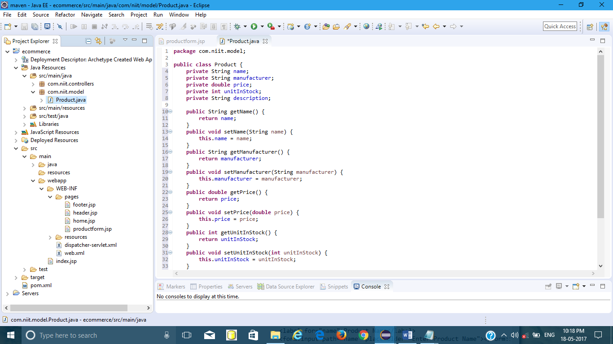

Now create controller for Product i.e create ProductController.java under com.niit.controllers as shown

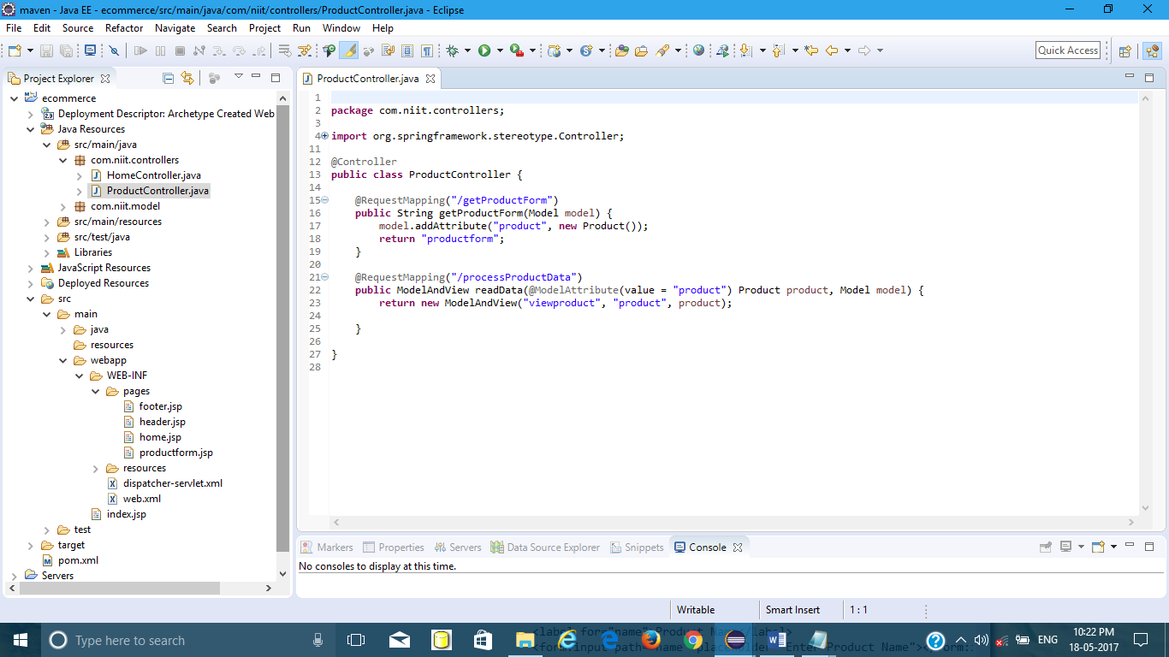

Create viewproduct.jsp to show product Details entered by user using form.

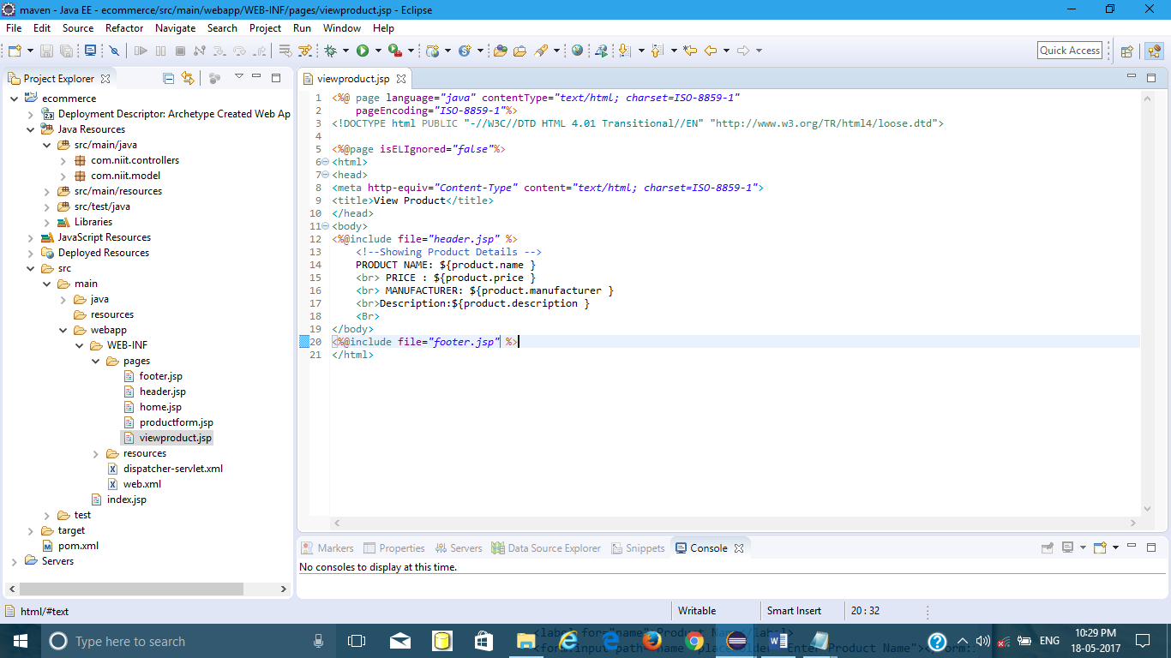

Now run this project on server .

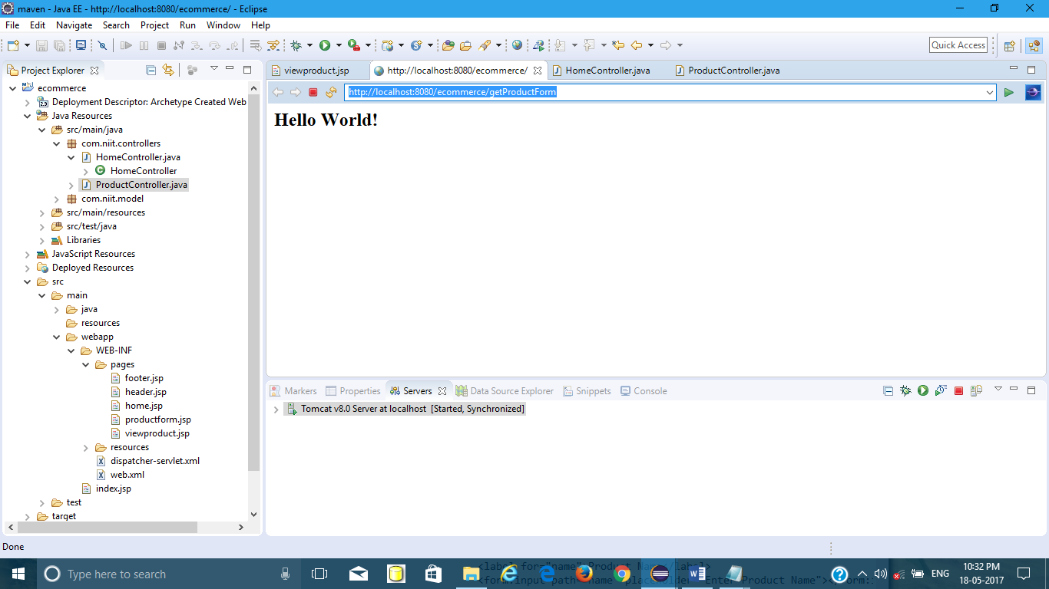

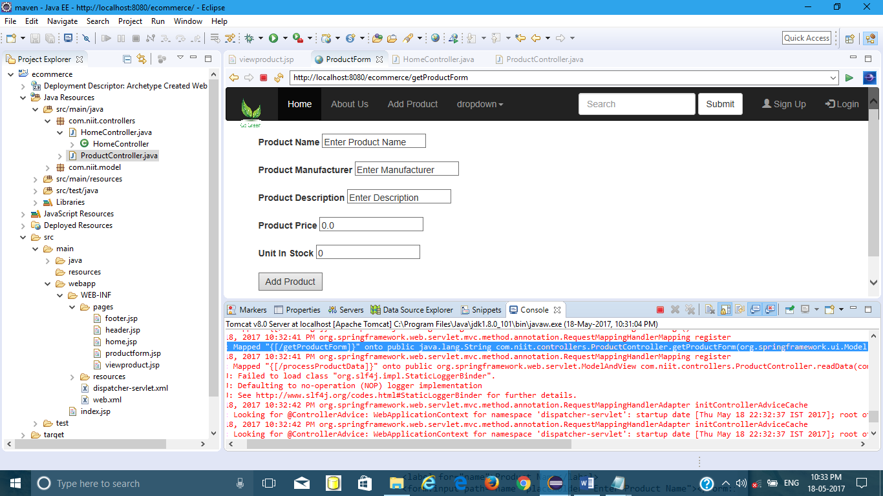

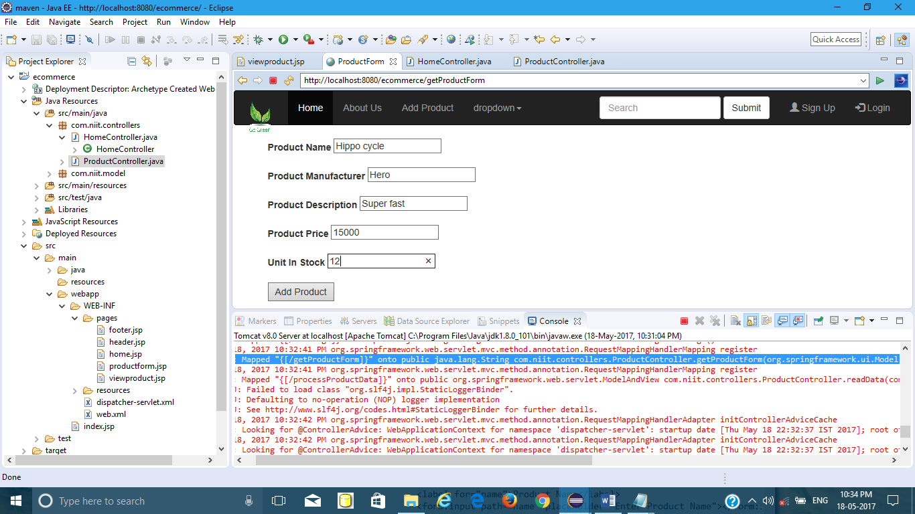

Once you press Add Product button, you are redirected to page viewproduct.java following url

http://localhost:8080/ecommerce/processProductData

